<https://www.youtube.com/watch?v=4jRBRDbJemM&list=PLblh5JKOoLUICTaGLRoHQDuF_7q2GfuJF&index=6>

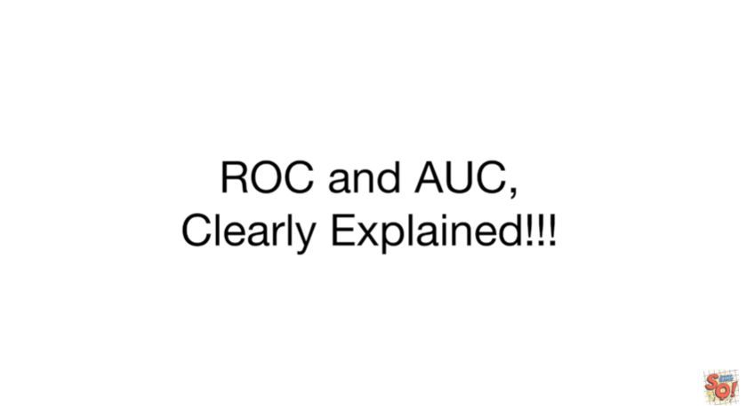

Today we're going to talk about ROC and AUC and they're going to be clearly explained.

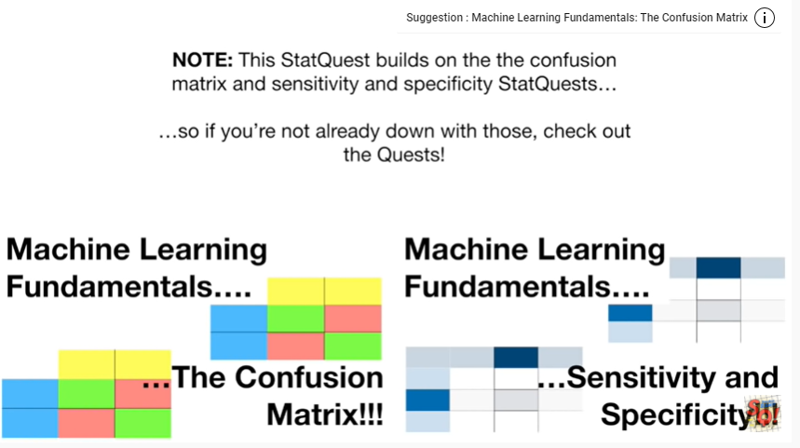

Note : this stack quest builds on the confusion matrix and sensitivity and specificity stack quests so if you're not already down with those check out the quests.

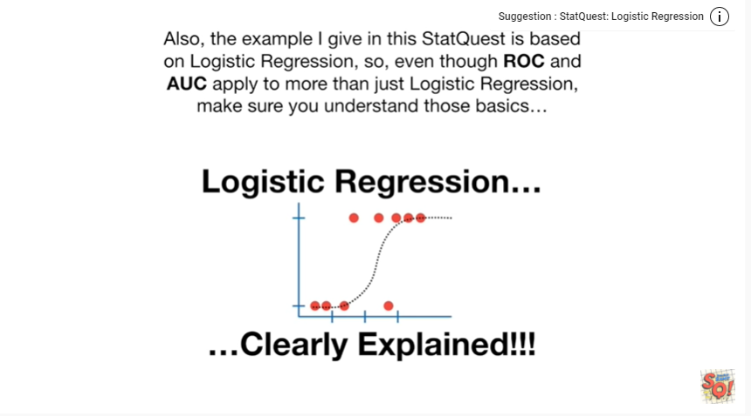

Also the example I given this stack quest is based on logistic regression so even though ROC and AUC apply to more than just logistic regression make sure you understand those basics.

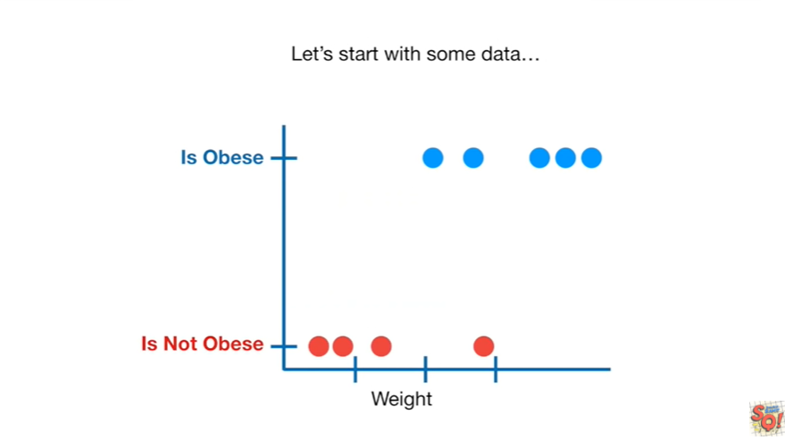

Let's start with some data.

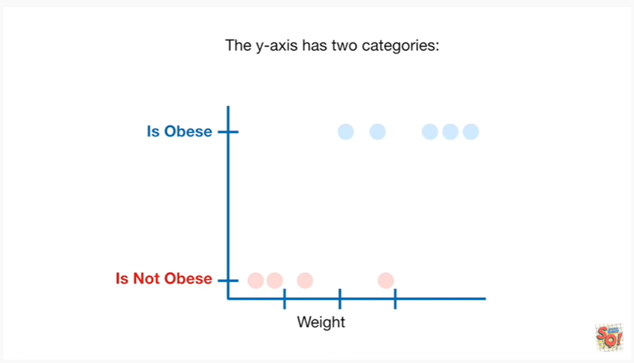

The y-axis has two categories :

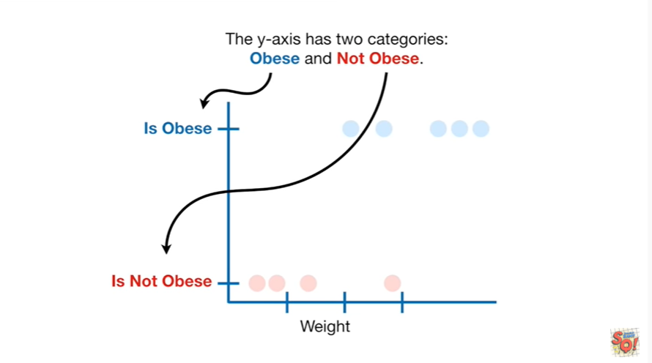

obese and not obese.

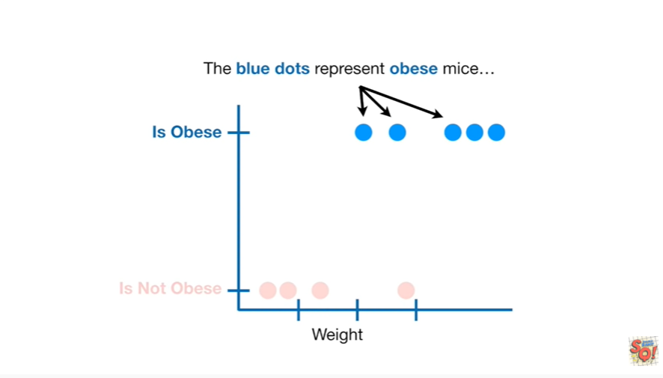

The blue dots represent obese mice

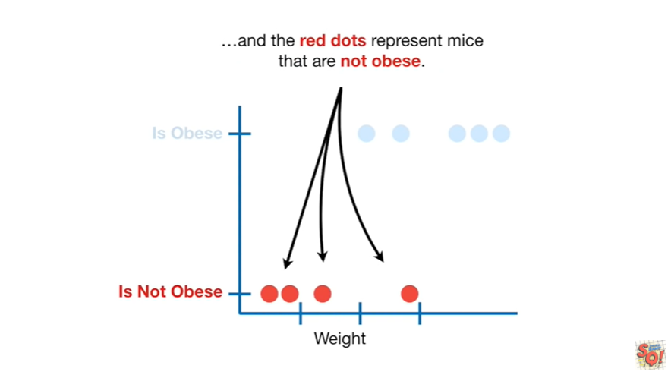

and the red dots represent mice that are not obese.

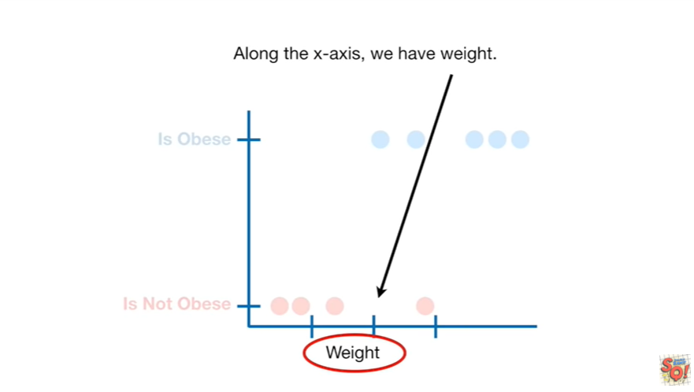

Along the x-axis we have weight.

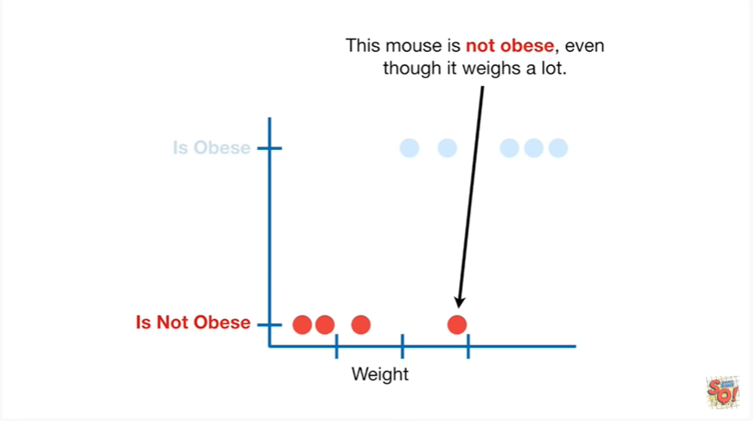

This mouse is not obese even though it weighs a lot.

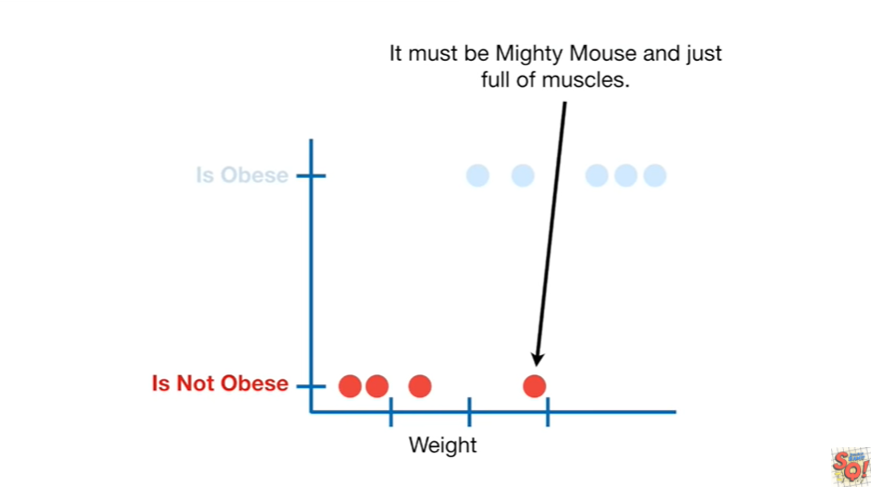

It must be Mighty Mouse in just full of muscles.

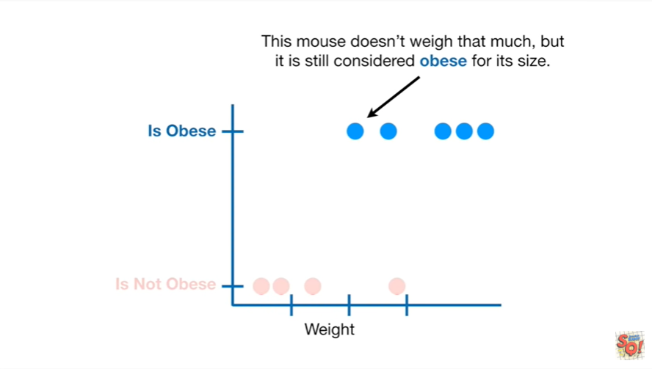

This mouse doesn't weigh that much but it is still considered obese for its size.

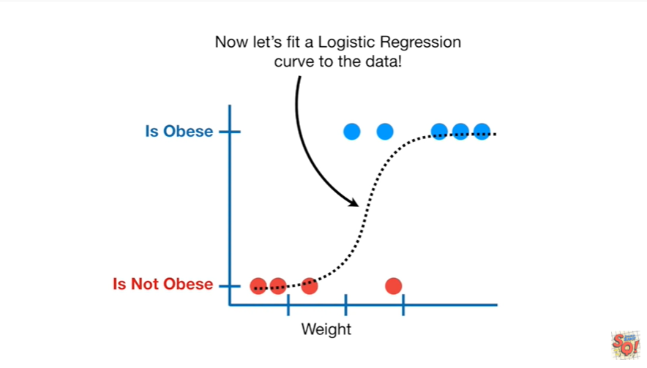

Now let's fit a logistic regression curve to the data.

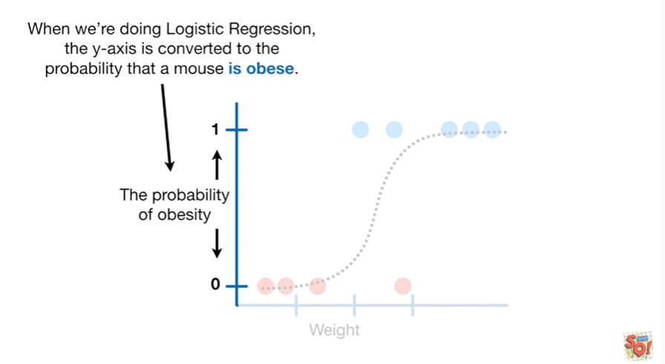

When we're doing logistic regression the y axis is converted to the probability that a mouse is obese.

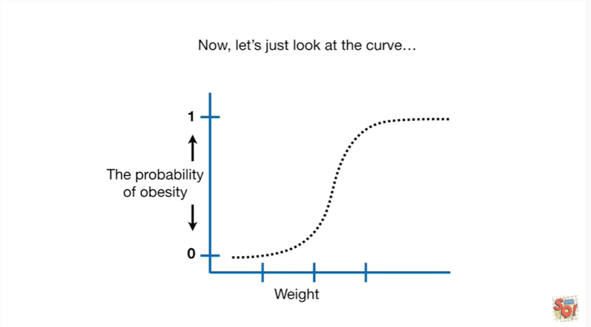

Now let's just look at the curve.

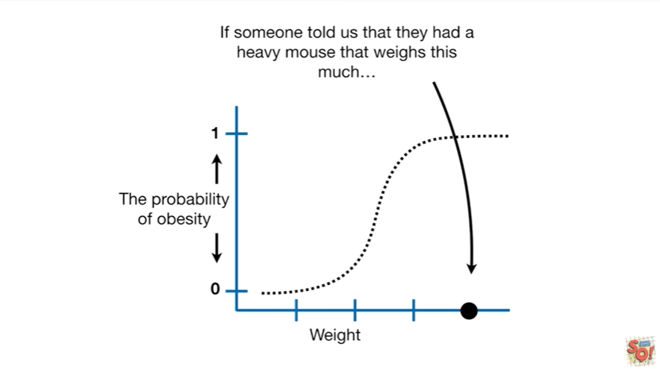

If someone told us that they had a heavy Mouse that weighs this much

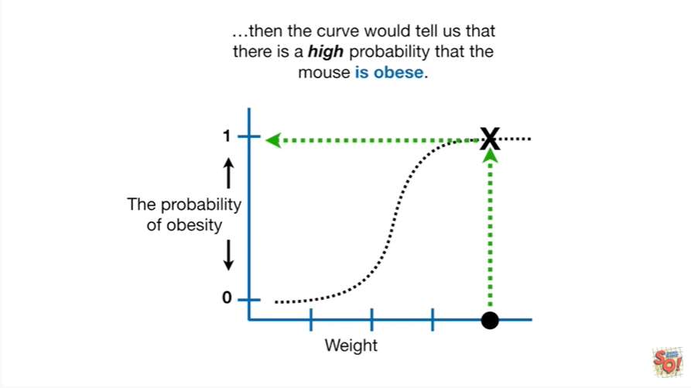

then the curve would tell us that there is a high probability that the mouse is obese.

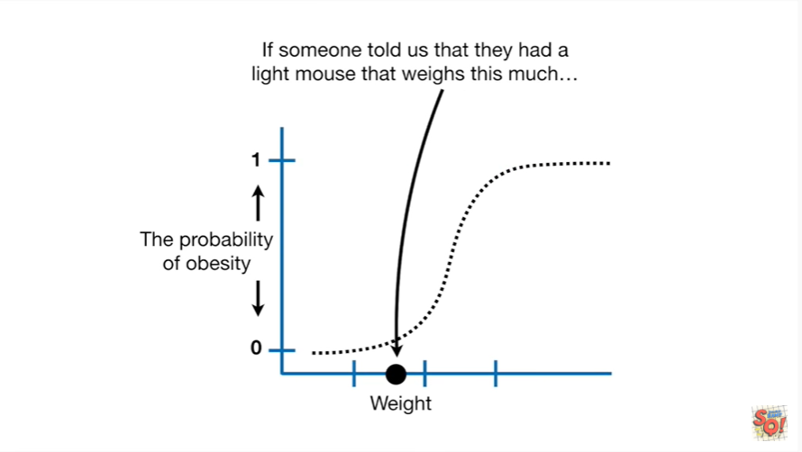

If someone told us that they had a light Mouse that weighs this much

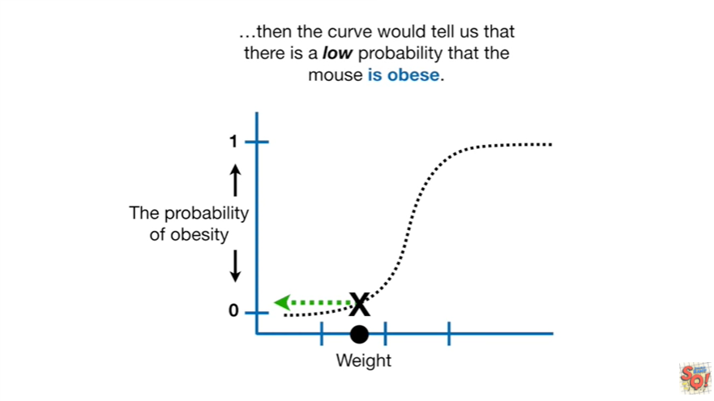

then the curve would tell us that there is a low probability that the mouse is obese.

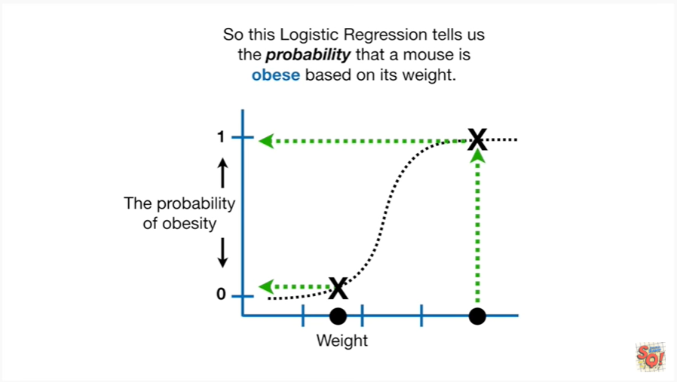

So this logistic regression tells us the probability that a mouse is obese based on its weight.

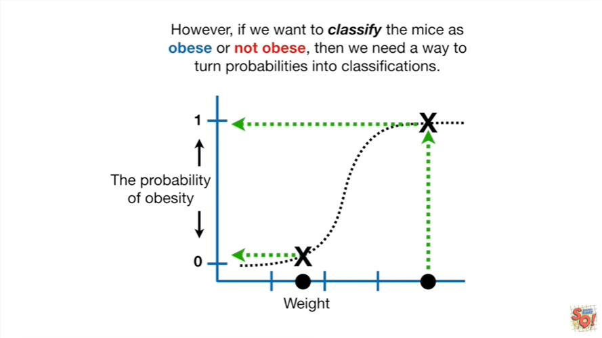

However if we want to classify the mice as obese or not obese then we need a way to turn probabilities into classifications.

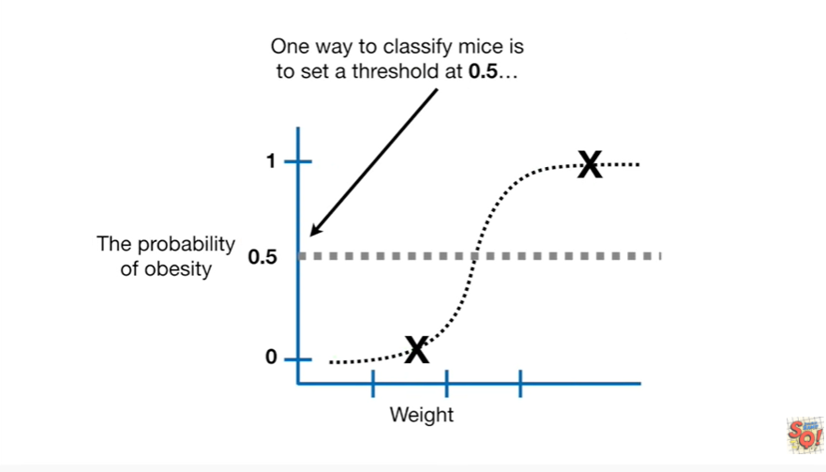

One way to classify mice is to set a threshold at 0.5

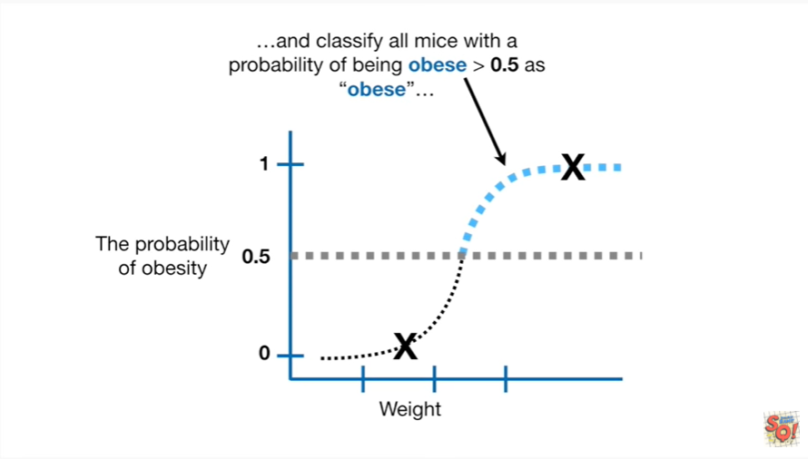

and classify all mice with a probability of being obese greater than 0.5 as obese

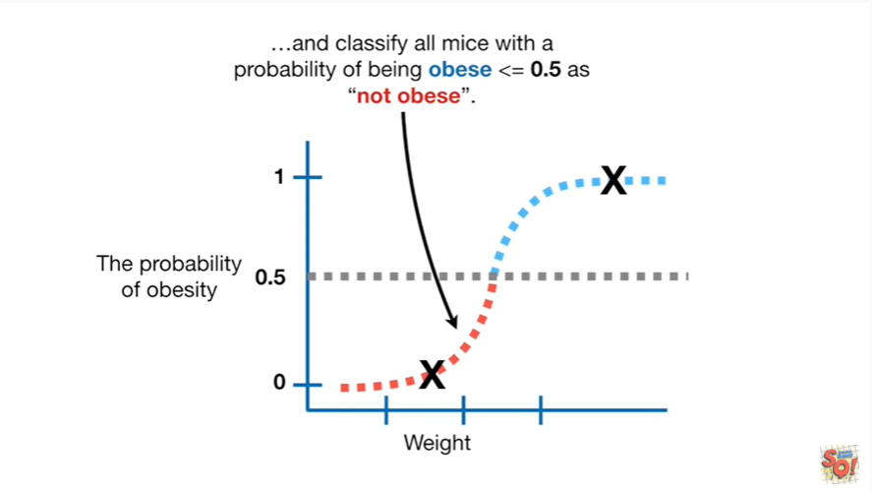

and classify all mice with the probability of being obese less than or equal to 0.5 as not obese.

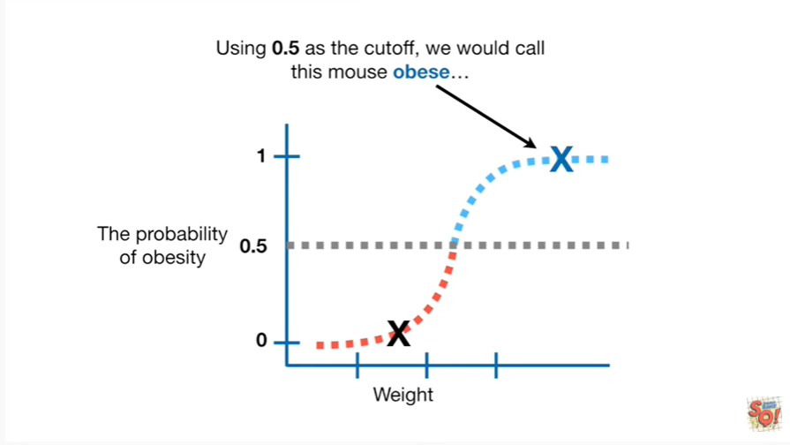

Using 0.5 as the cutoff we would call this Mouse obese

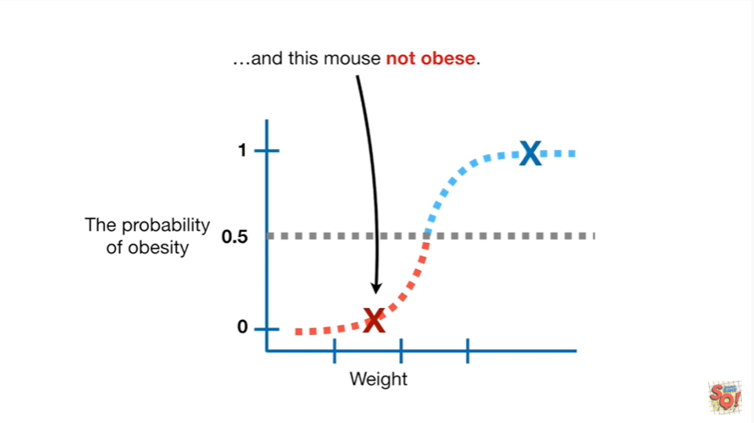

and this mouse not obese.

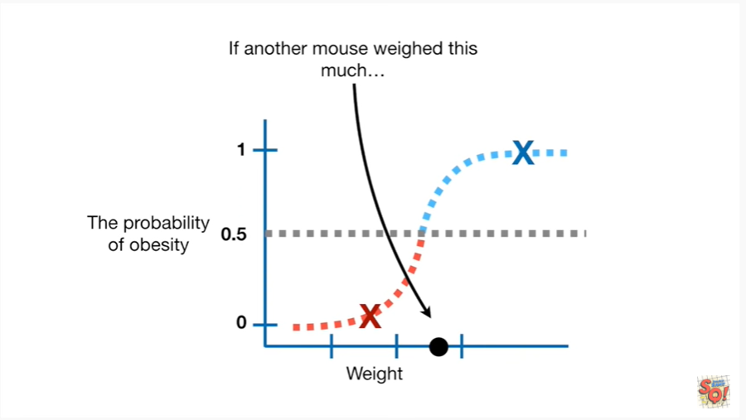

If another Mouse weighed this much

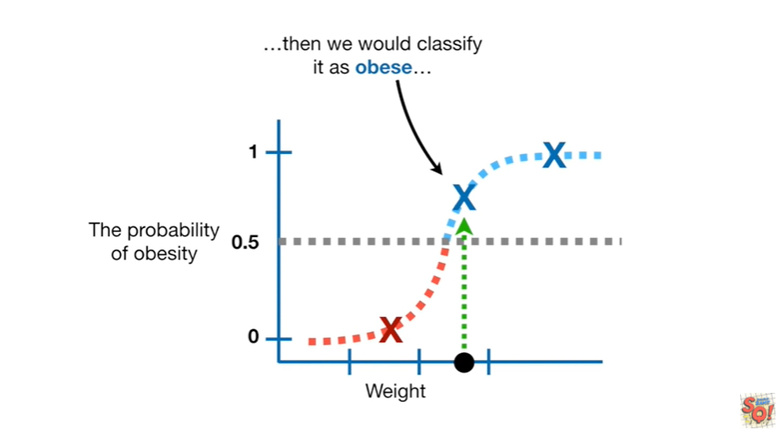

then we would classify it as obese

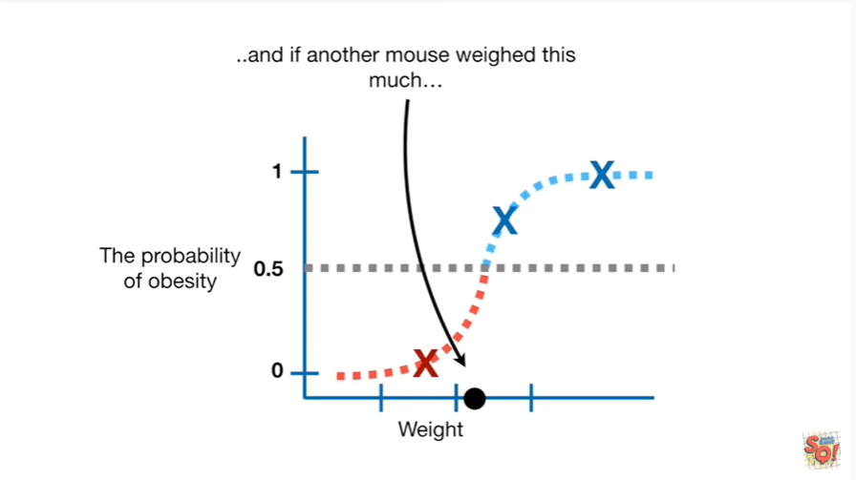

and if another Mouse weighed this much

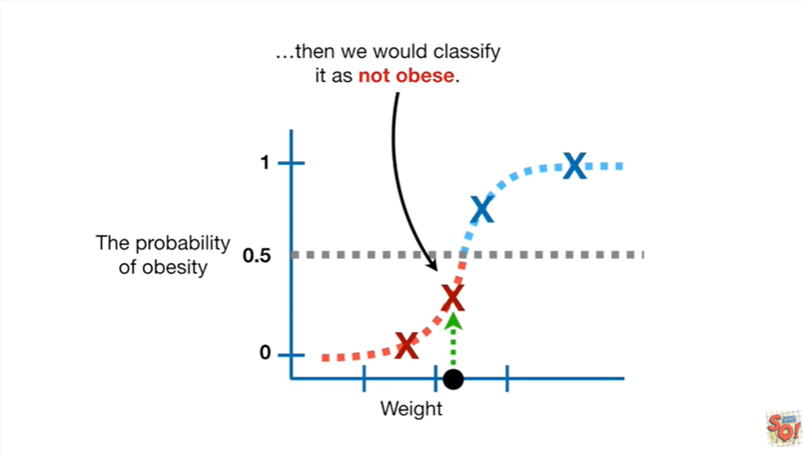

then we would classify it as not obese.

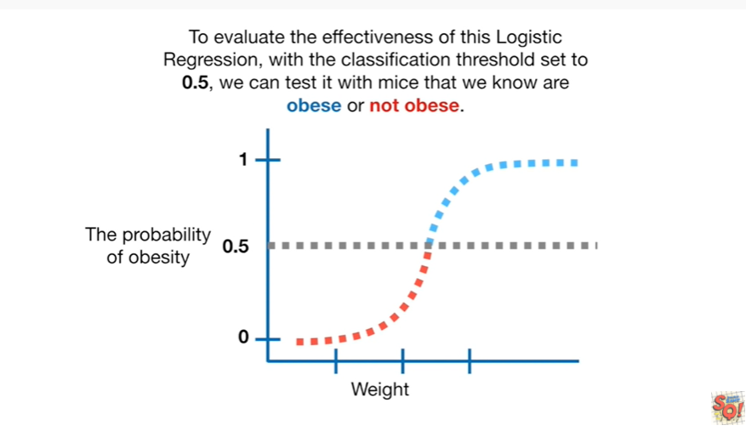

To evaluate the effectiveness of this logistic regression with the classification threshold set to 0.5 we can test it with mice that we know are obese and not obese.

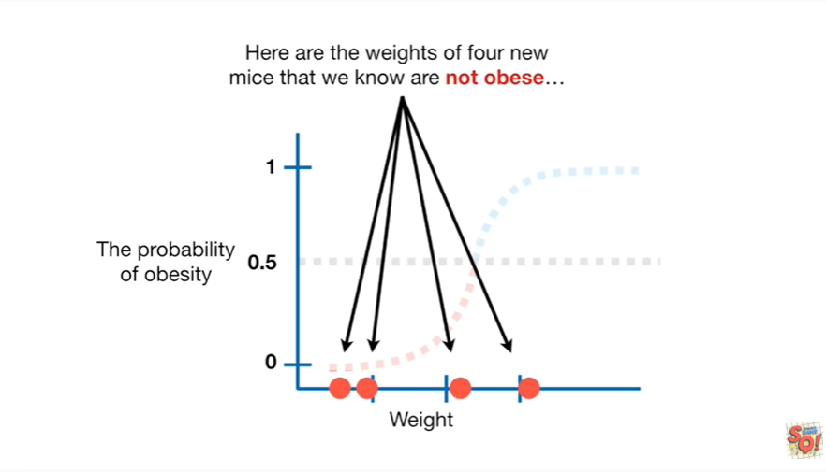

Here are the weights of four new mice that we know are not obese

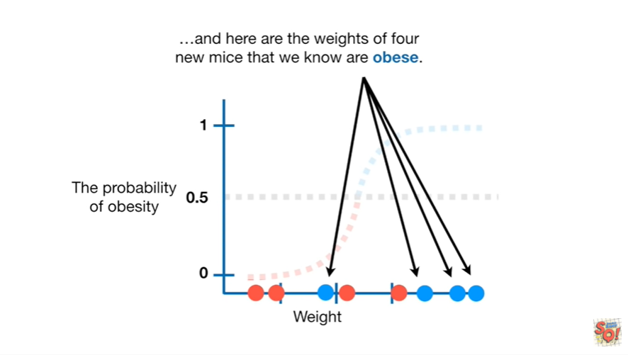

and here are the weights of four new mice that we know are obese.

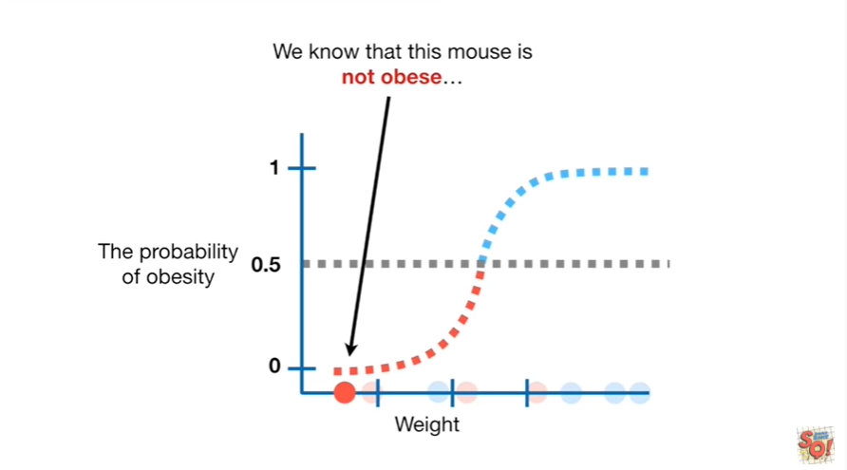

We know that this mouse is not obese

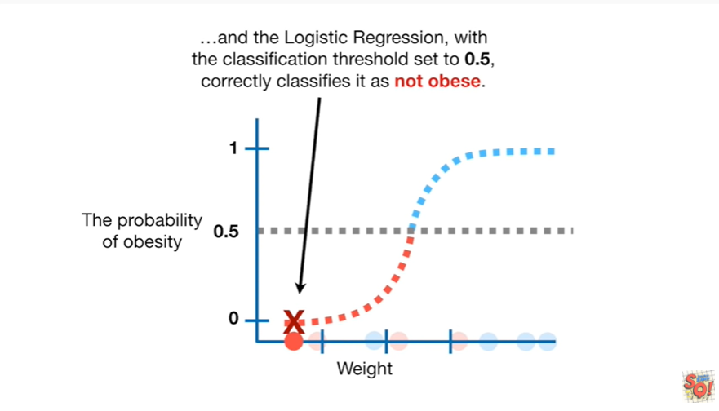

and the logistic regression with the classification threshold set to 0.5 correctly classifies it as not obese.

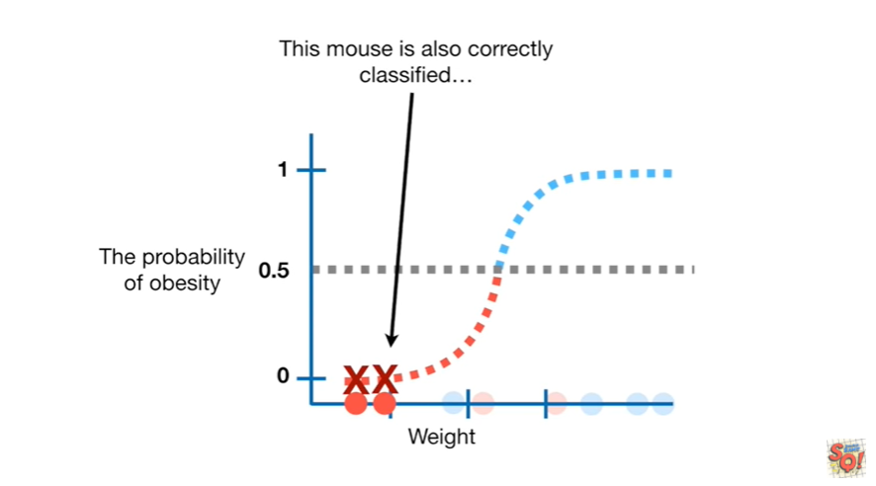

This mouse is also correctly classified

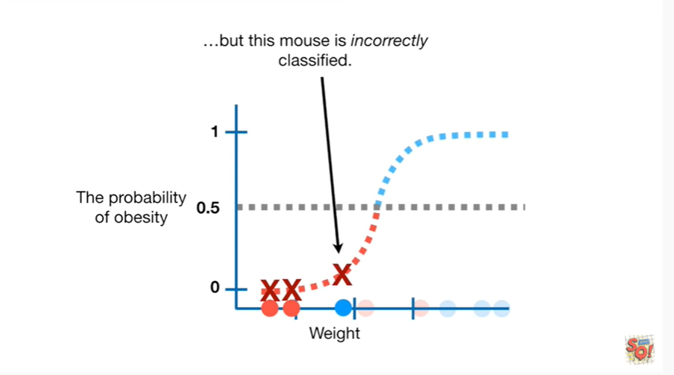

but this mouse is incorrectly classified.

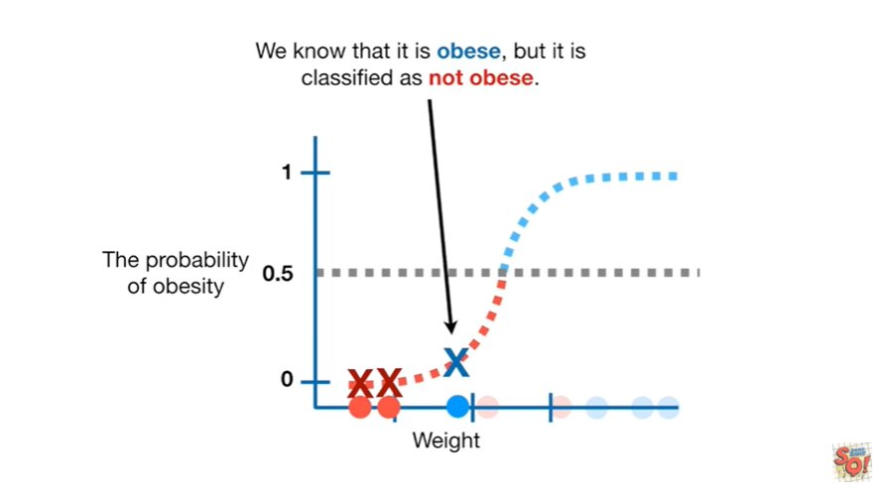

We know that it is obese but it is classified as not obese.

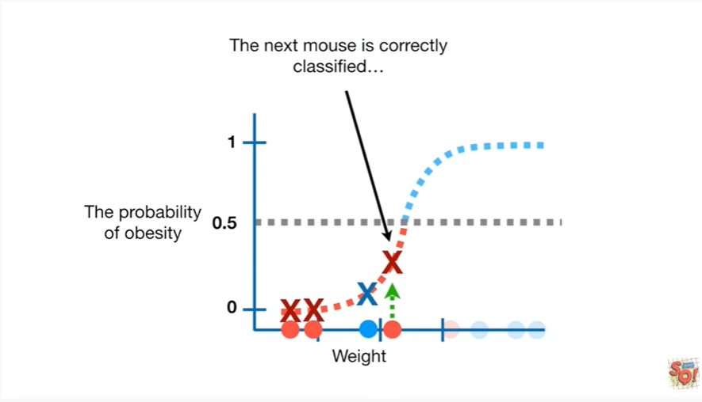

The next Mouse is correctly classified

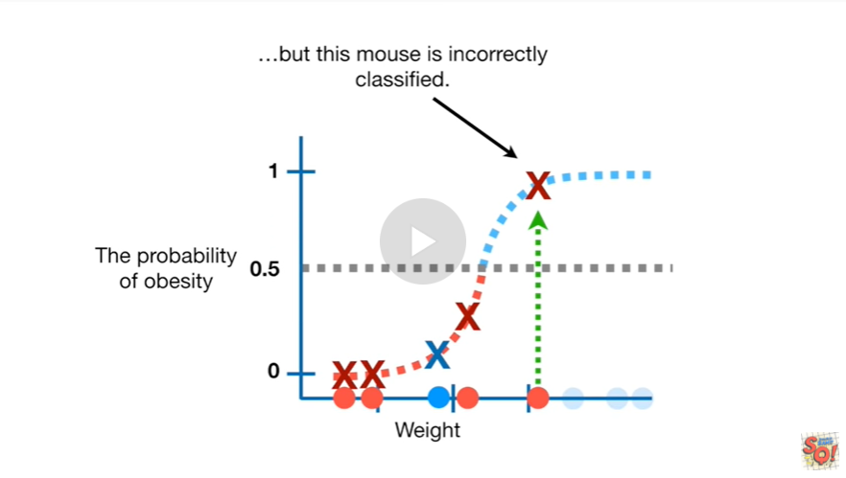

but this mouse is incorrectly classified.

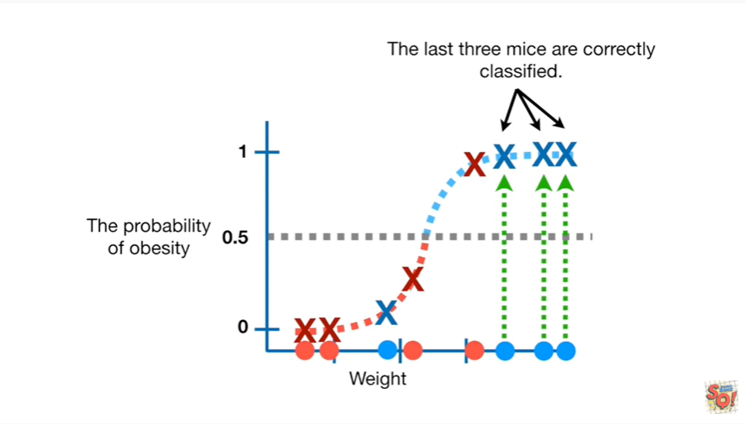

The last three mice are correctly classified.

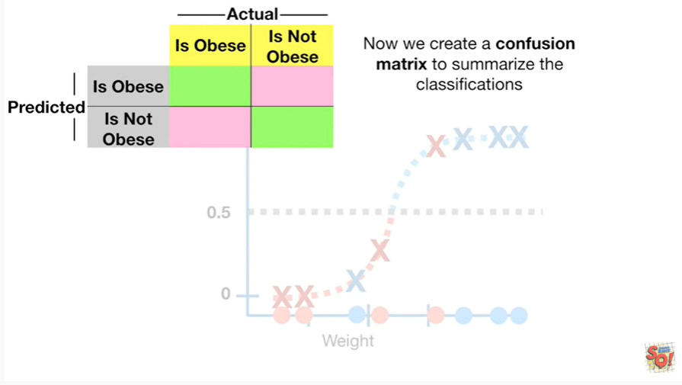

Now we create a confusion matrix to summarize the classifications.

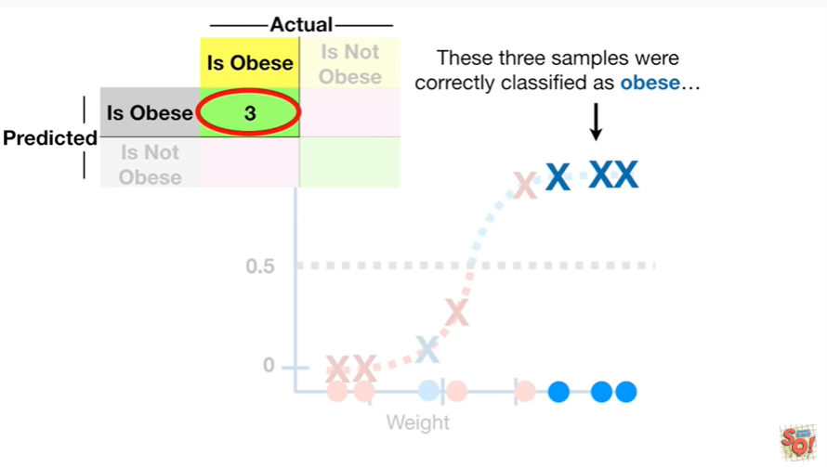

These three samples were correctly classified as obese

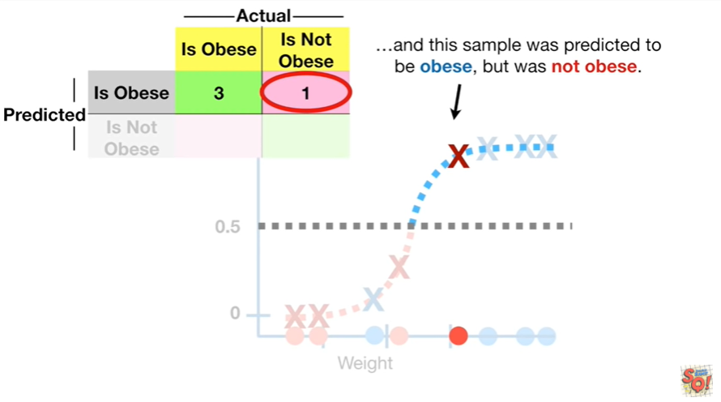

and this sample was predicted to be obese but was not obese.

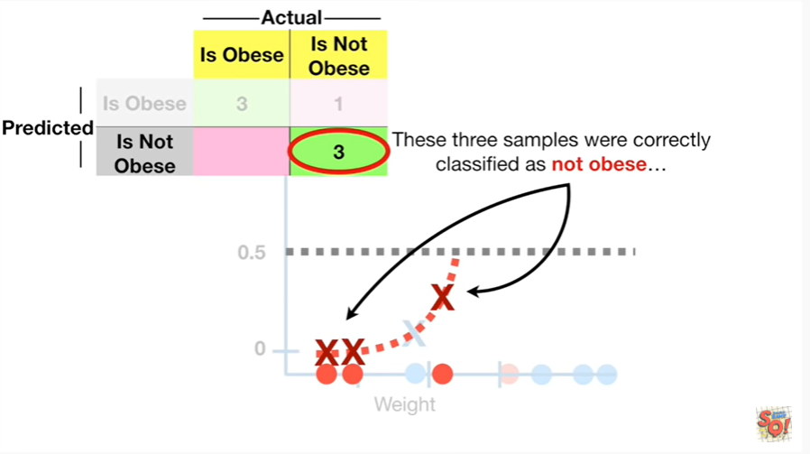

These three samples were correctly classified as not obese

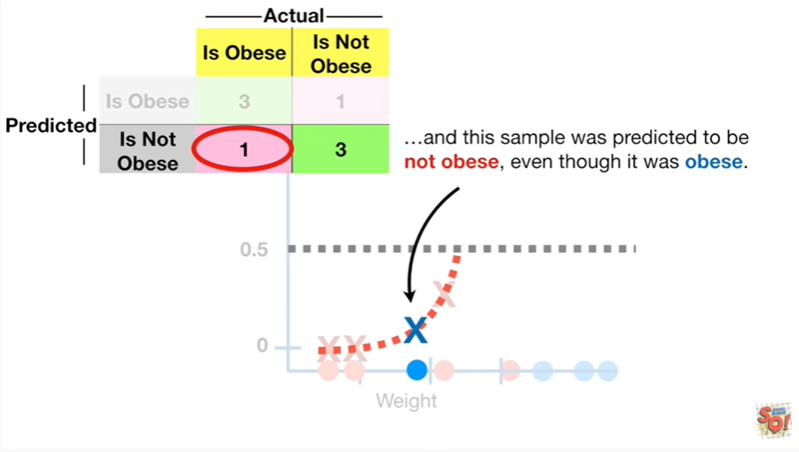

and this sample was predicted to be not obese even though it was obese.

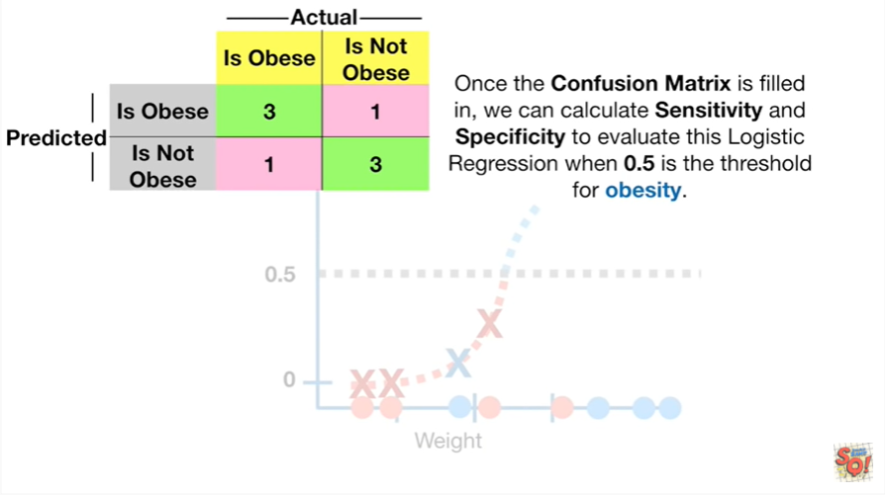

Once the confusion matrix is filled in we can calculate sensitivity and specificity to evaluate this logistic regression when 0.5 is the threshold for obesity.

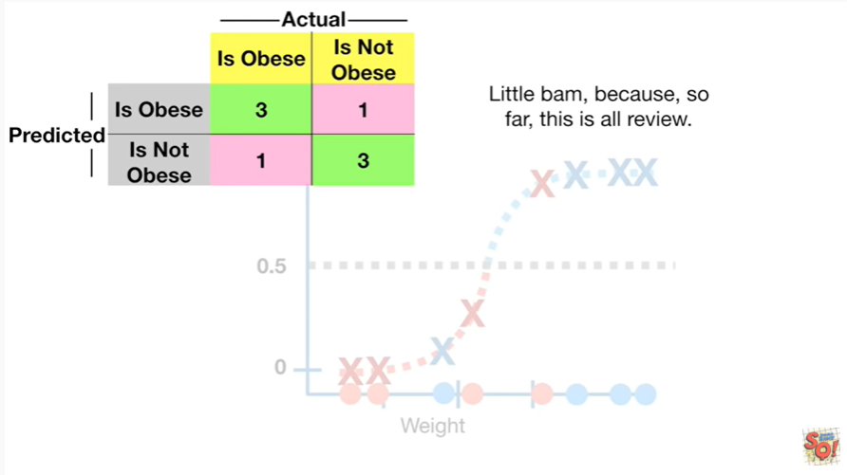

Little BAM because so far this is all review.

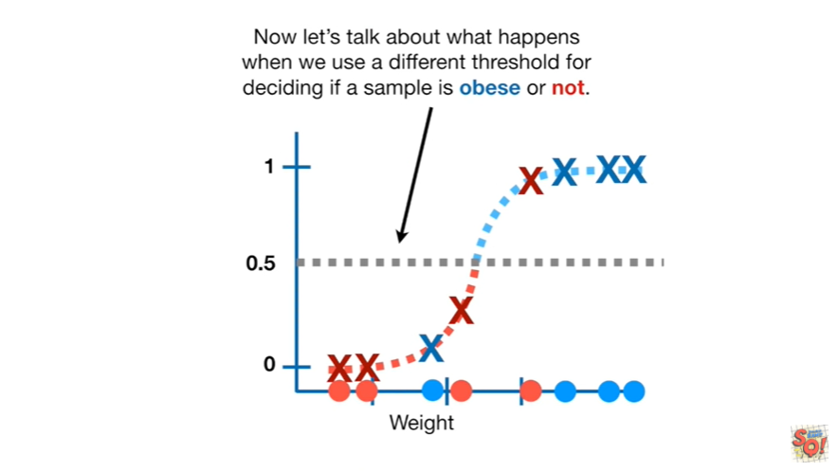

Now let's talk about what happens when we use a different threshold for deciding if a sample is obese or not.

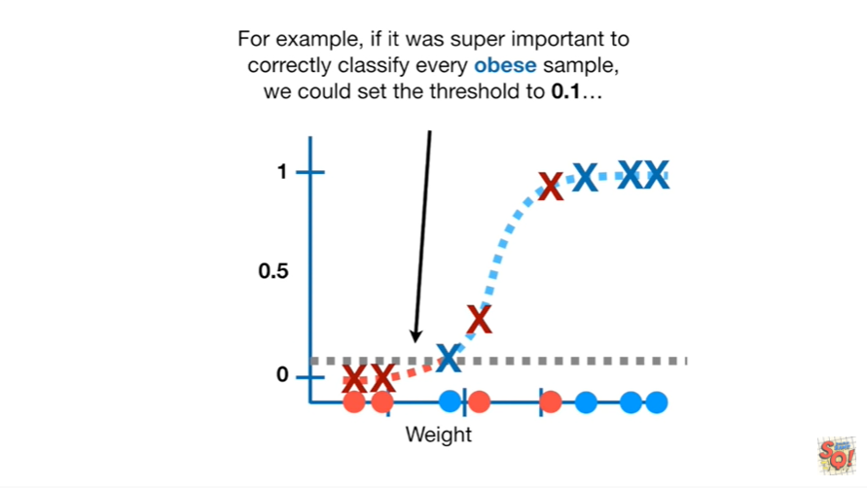

For example if it was super important to correctly classify every obese sample we could set the threshold to 0.1.

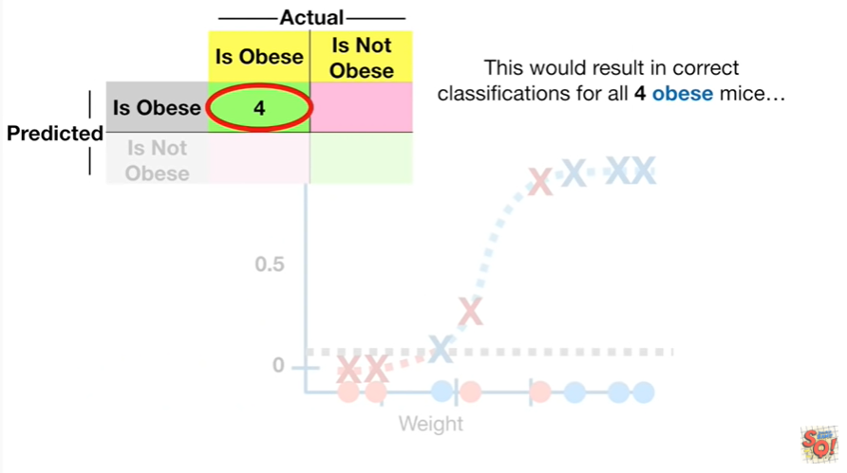

This would result in correct classifications for all for obese mice

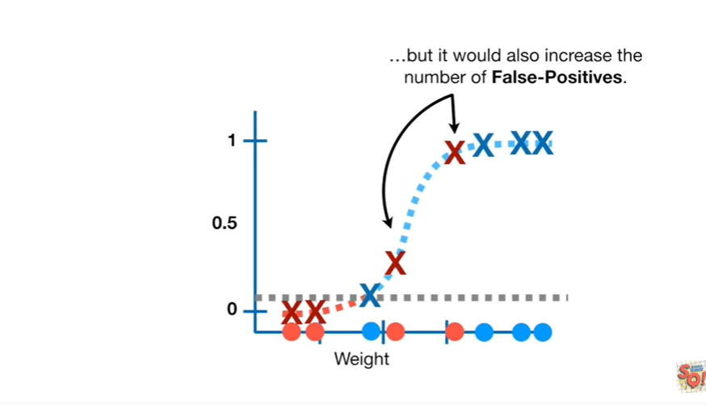

but it would also increase the number of false positives.

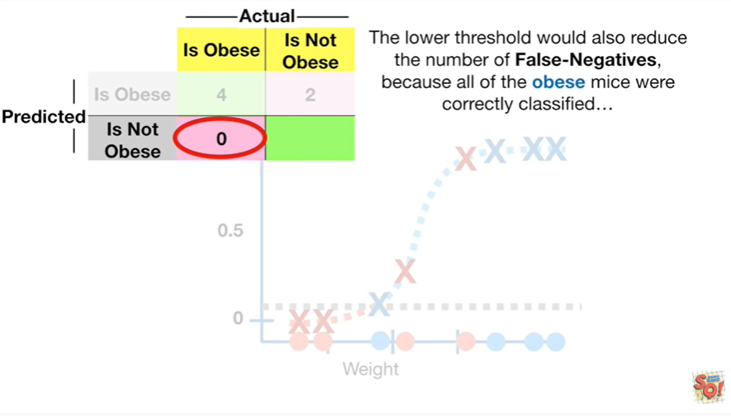

The lower threshold would also reduce the number of false negatives because all of the obese mice were correctly classified

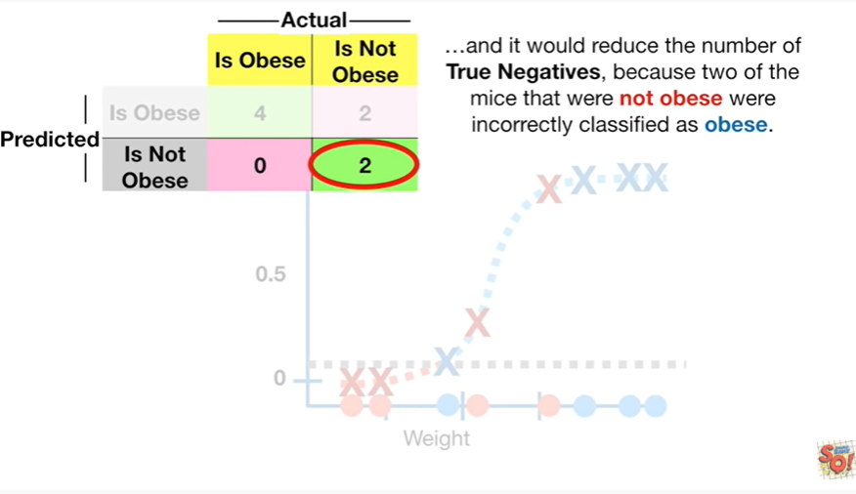

and it would reduce the number of true negatives because two of the mice that were not obese were incorrectly classified as obese.

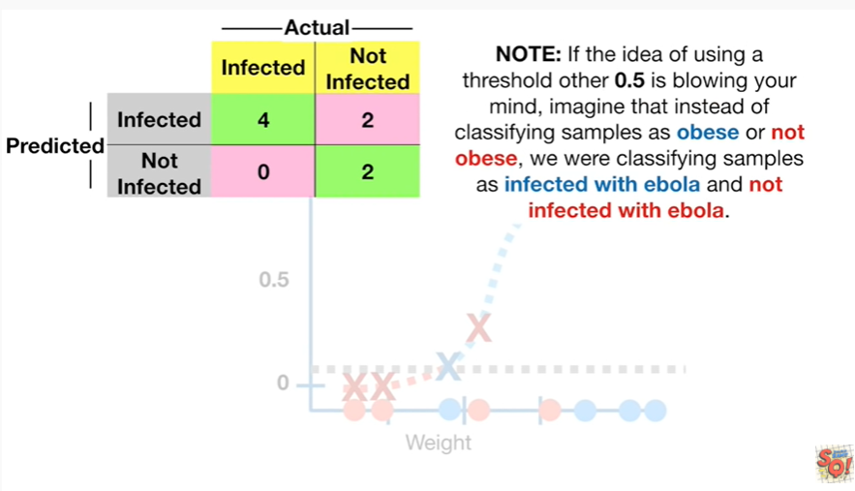

Note if the idea of using a threshold other than 0.5 is blowing your mind imagine that instead of classifying samples as obese or not obese, we were classifying samples as infected with Ebola and not infected with Ebola.

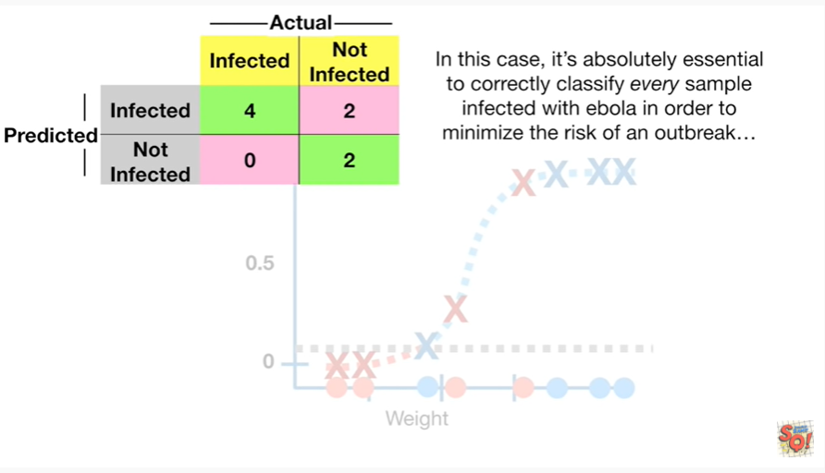

In this case it's absolutely essential to correctly classify every sample infected with Ebola in order to minimize the risk of an outbreak

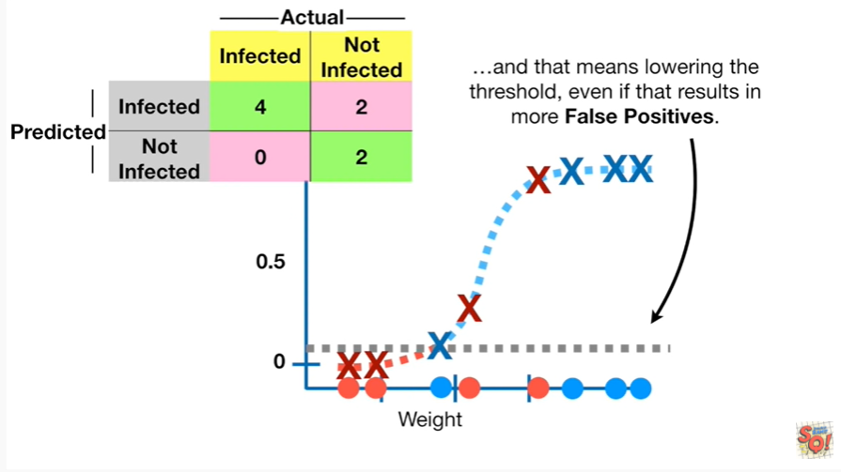

and that means lowering the threshold even if that results in more false positives.

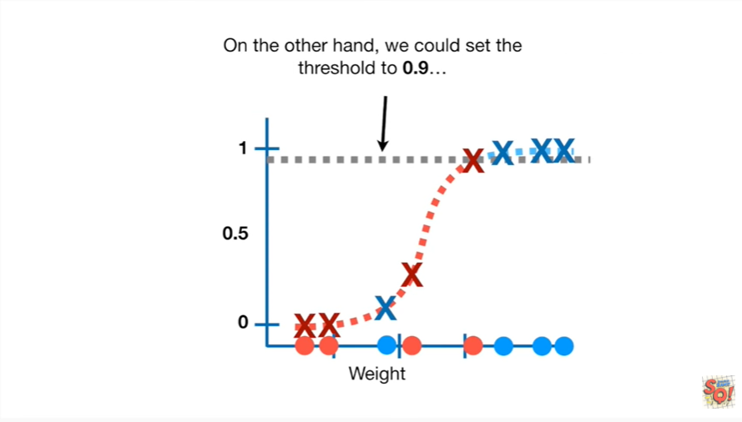

On the other hand we could set the threshold to 0.9.

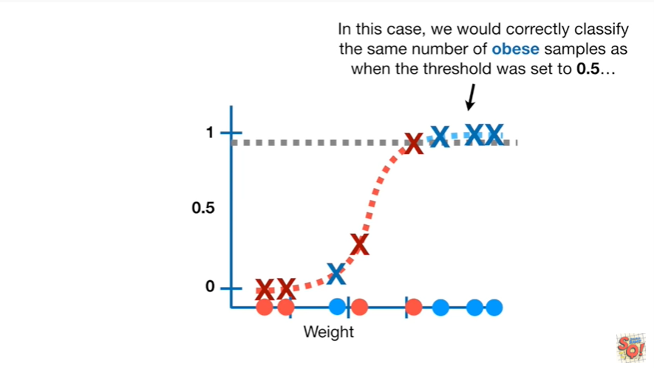

In this case we would correctly classify the same number of obese samples as when the threshold was set to 0.5

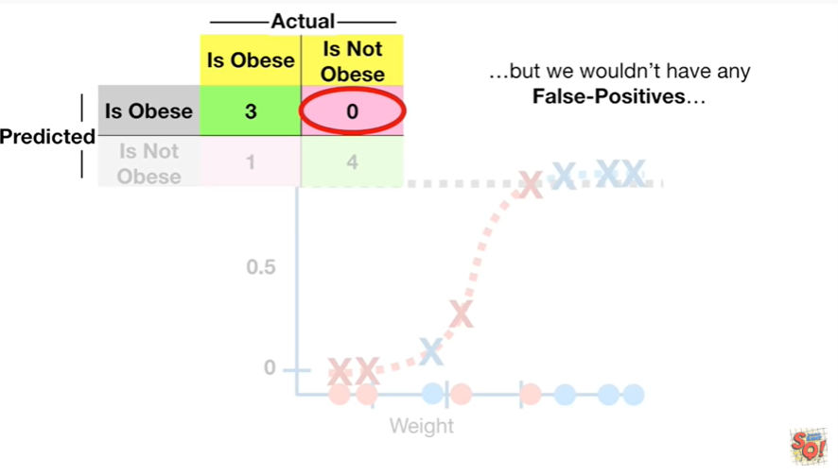

but we wouldn't have any false positives

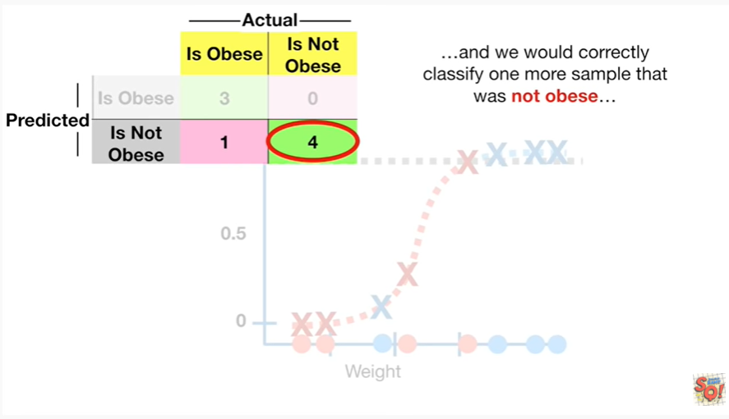

and we would correctly classify one more sample that was not obese

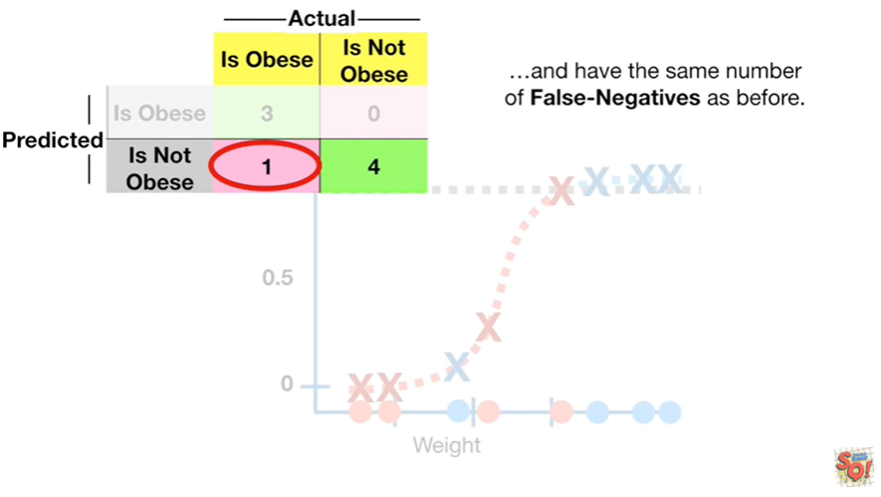

and have the same number of false negatives as before.

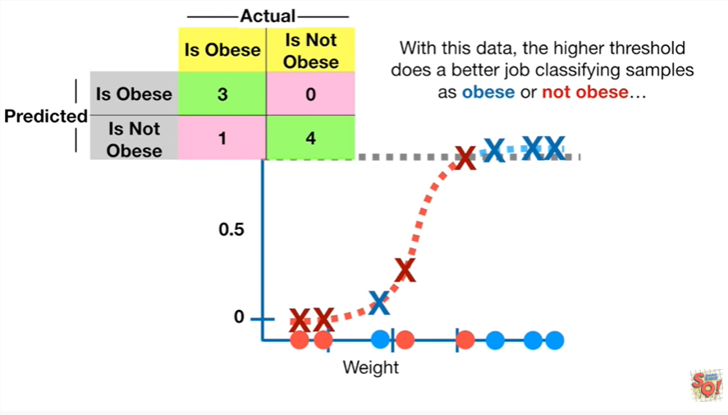

With this data the higher threshold does a better job classifying samples as obese or not obese

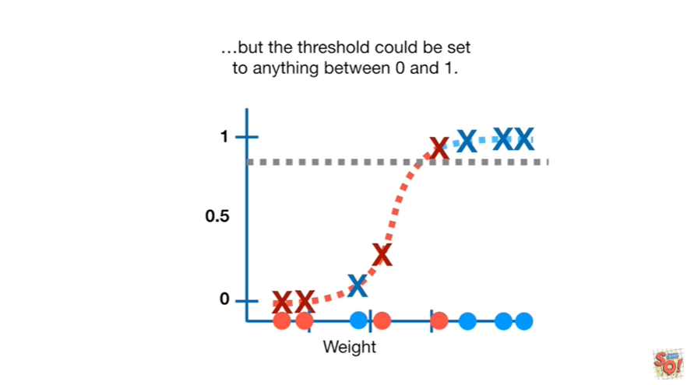

but the threshold could be set to anything between zero and one.

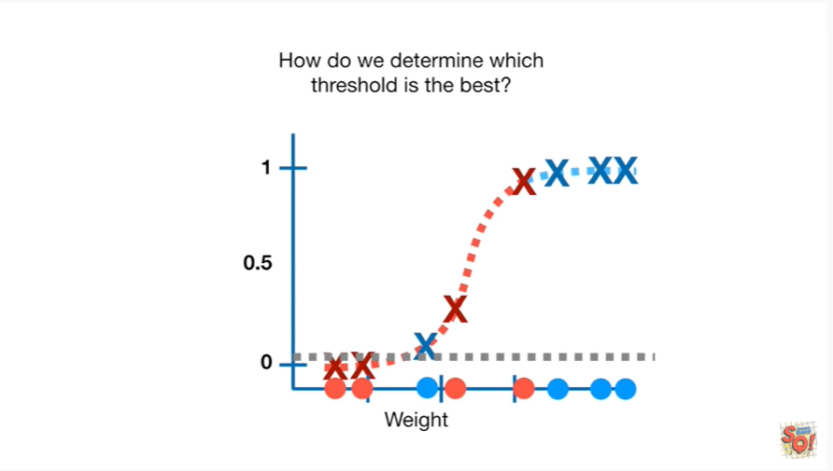

How do we determine which threshold is the best ?

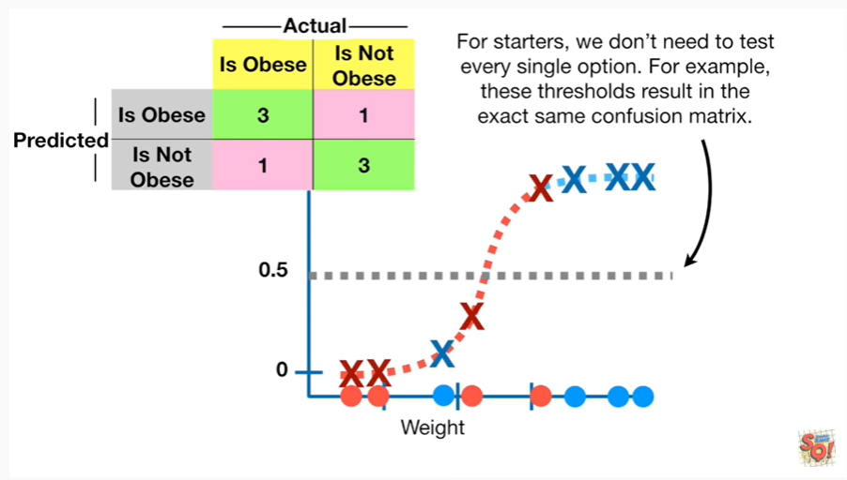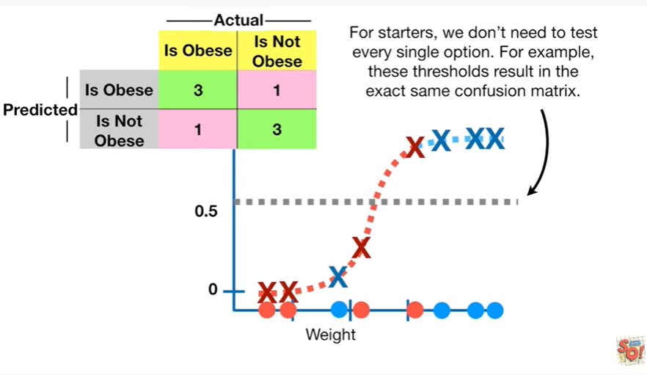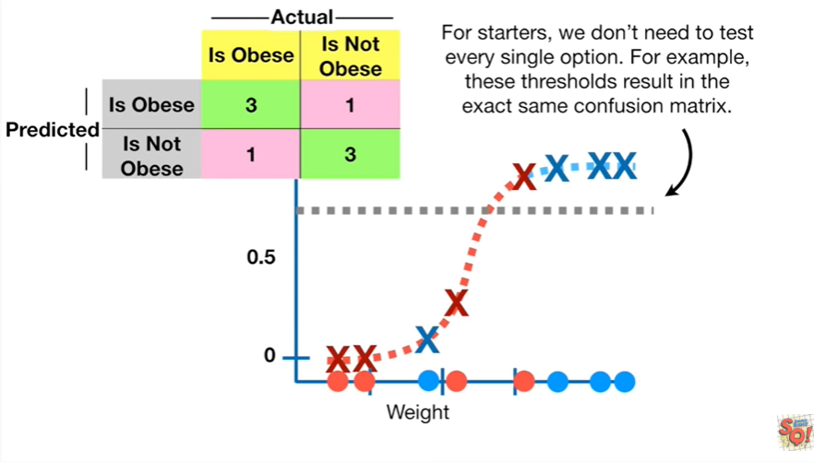

For starters we don't need to test every single option.

For example these thresholds result in the exact same confusion matrix.

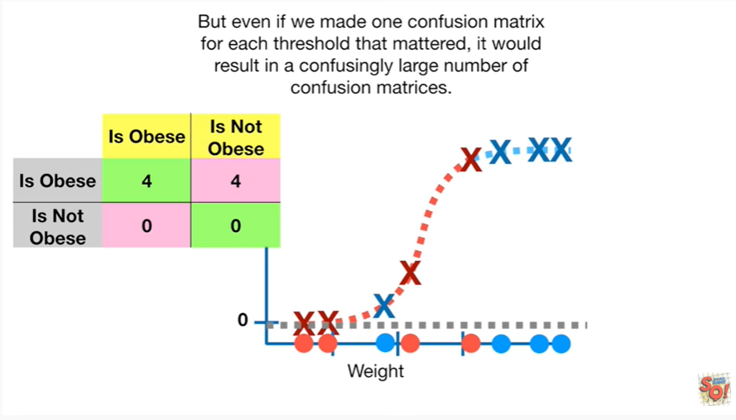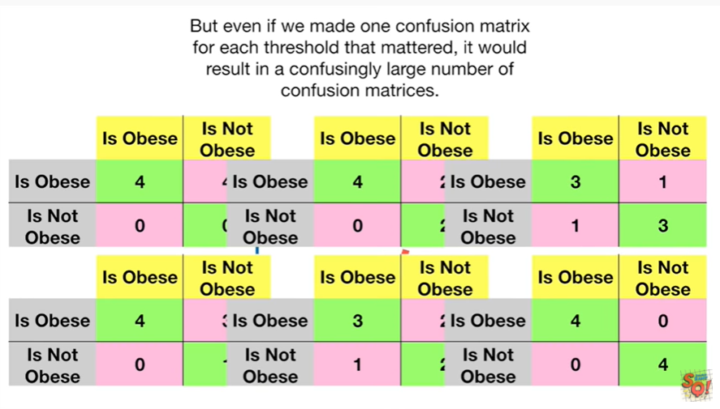

But even if we made one confusion matrix for each threshold that mattered it would result in a confusingly large number of confusion matrices.

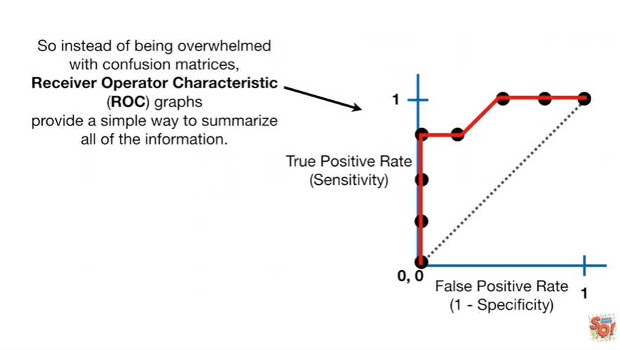

So instead of being overwhelmed with confusion matrices receiver operator characteristic ROC graphs provide a simple way to summarize all of the information.

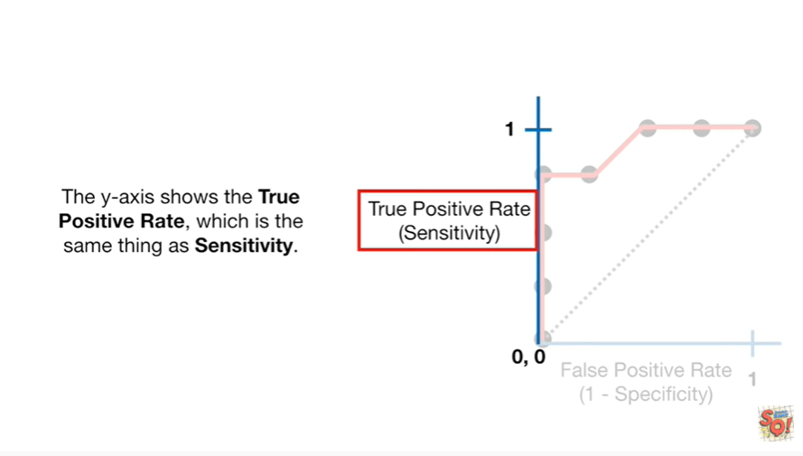

The y-axis shows the true positive rate which is the same thing as sensitivity.

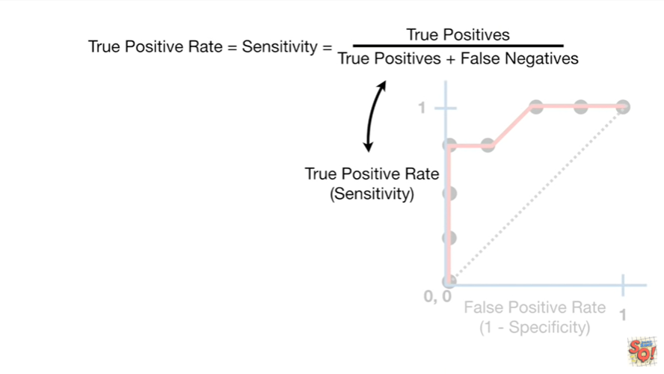

The true positive rate is the true positives divided by the sum of the true positives and the false negatives.

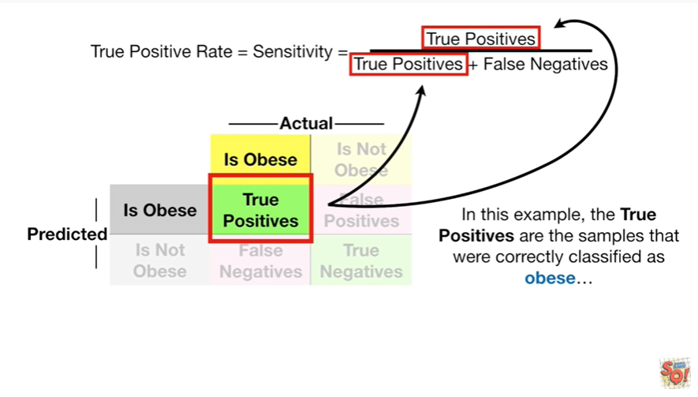

In this example the true positives are the samples that were correctly classified as obese.

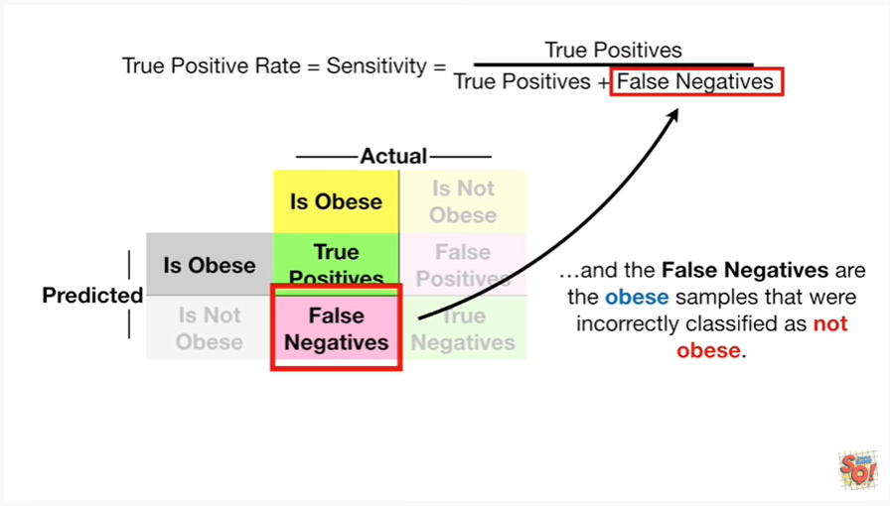

And the false negatives are the obese samples that were incorrectly classified as not obese.

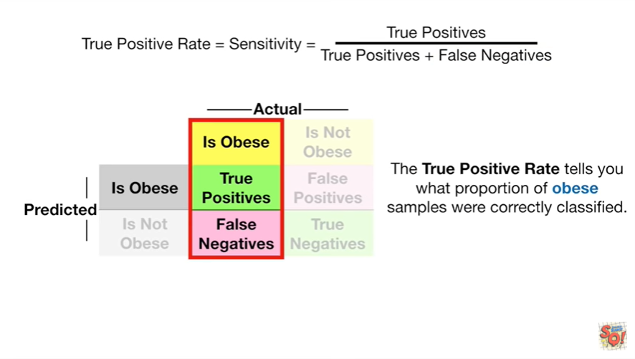

The true positive rate tells you what proportion of obese samples were correctly classified.

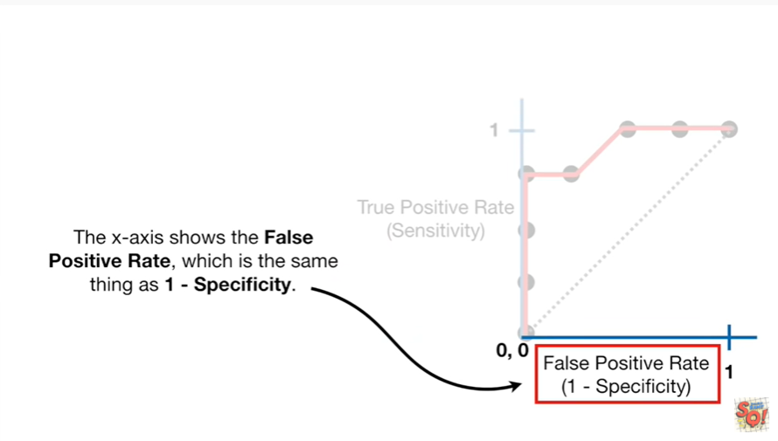

The x-axis shows the false positive rate which is the same thing as 1 minus specificity.

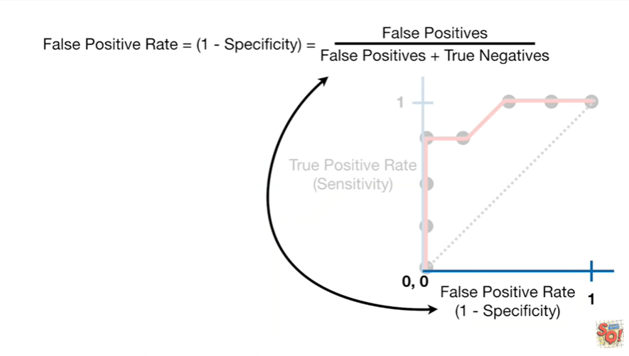

The false positive rate is the false positives divided by the sum of the false positives and true negatives.

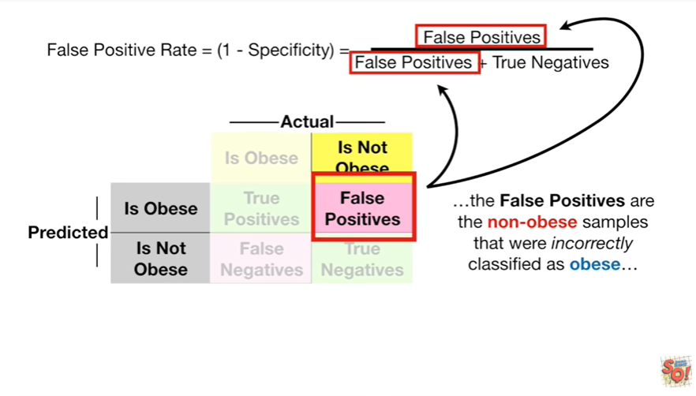

The false positives are the non obese samples that were incorrectly classified as obese

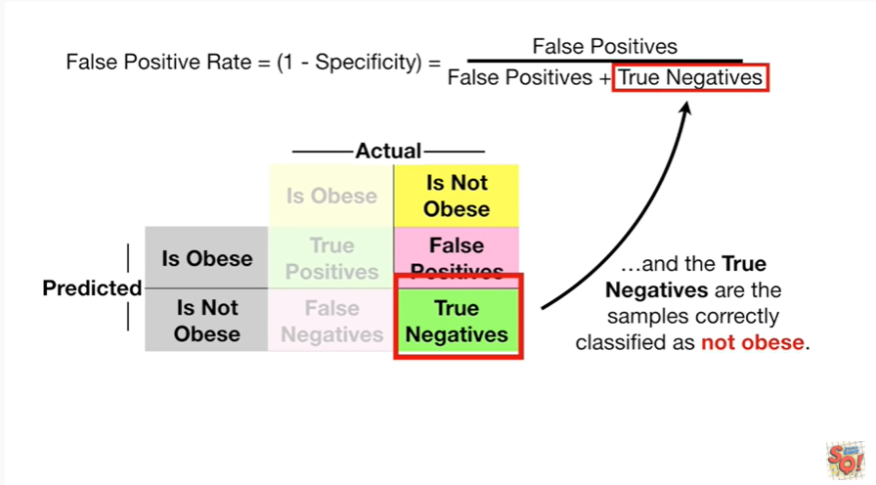

and the true negatives are the samples correctly classified as not obese.

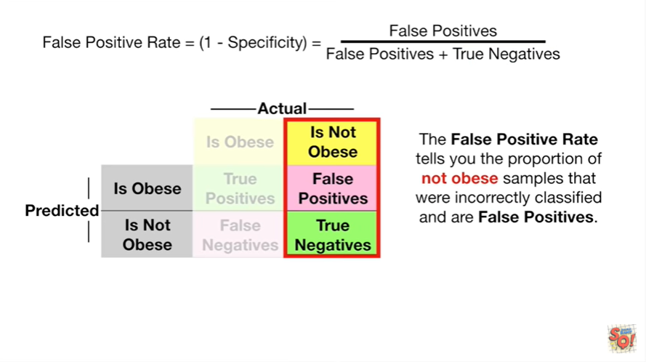

The false positive rate tells you the proportion of not obese samples that were incorrectly classified at our false positives.

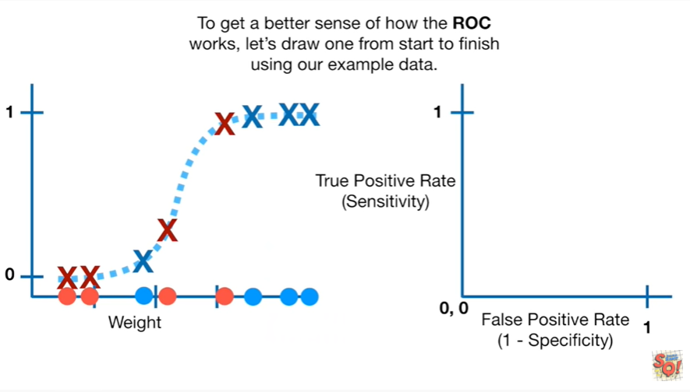

To get a better sense of how the ROC works let's draw one from start to finish using our example data.

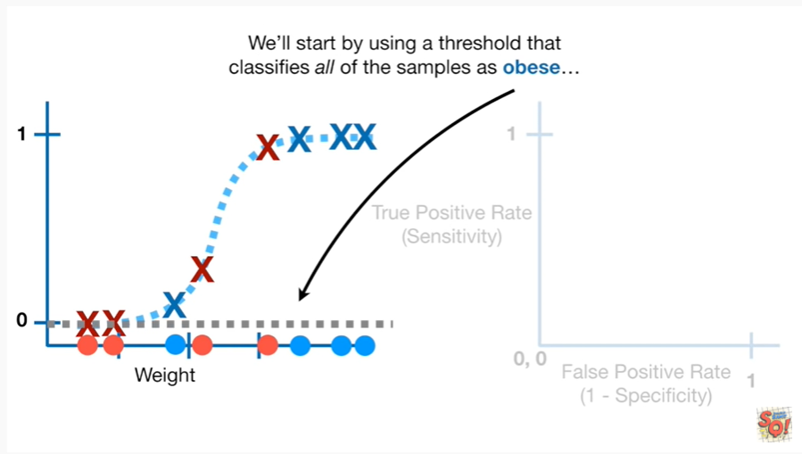

We'll start by using a threshold that classifies all of the samples as obese

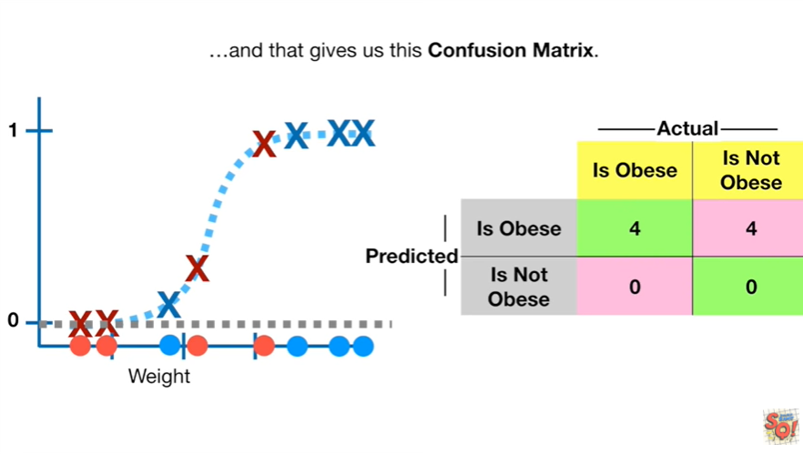

and that gives us this confusion matrix.

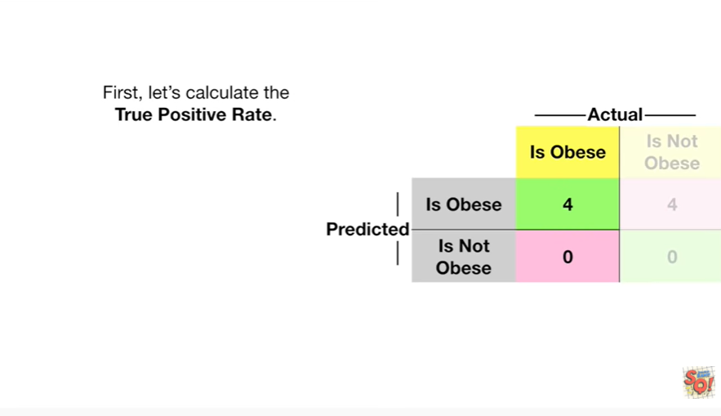

First let's calculate the true positive rate.

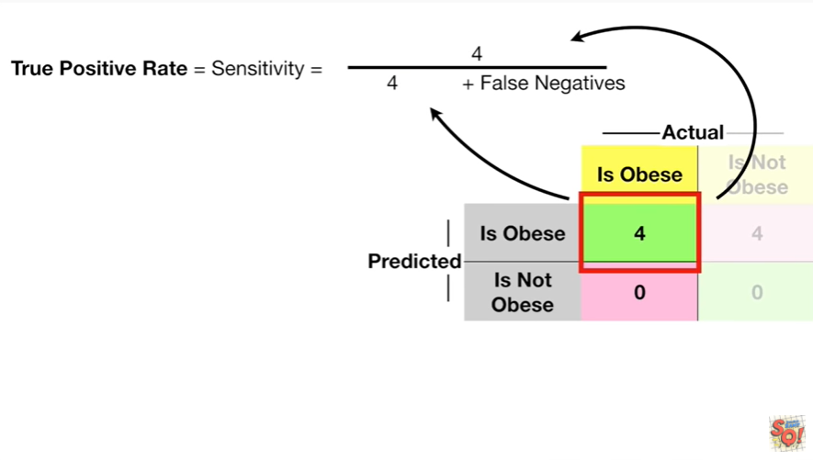

There are 4 true positives

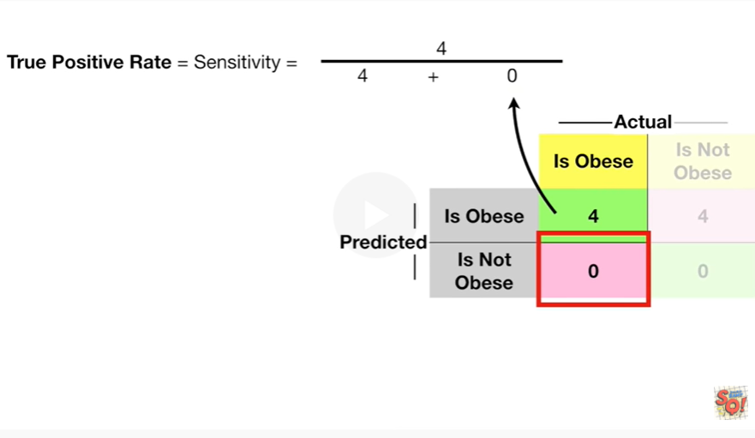

and there were 0 false negatives.

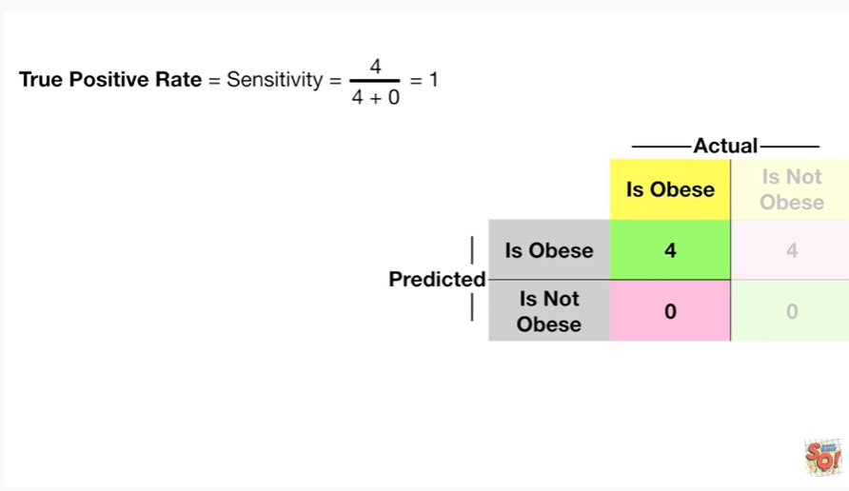

Doing the math gives us 1.

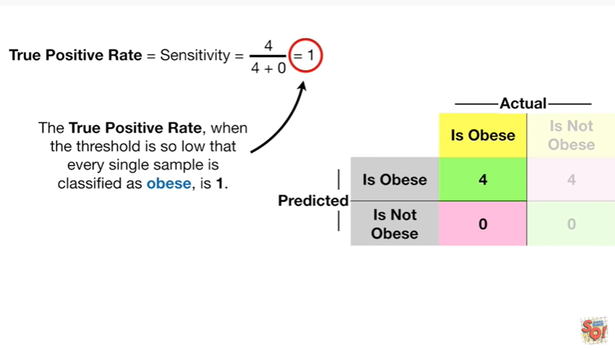

The true positive rate when the threshold is so low that every single sample is classified as obese is 1.

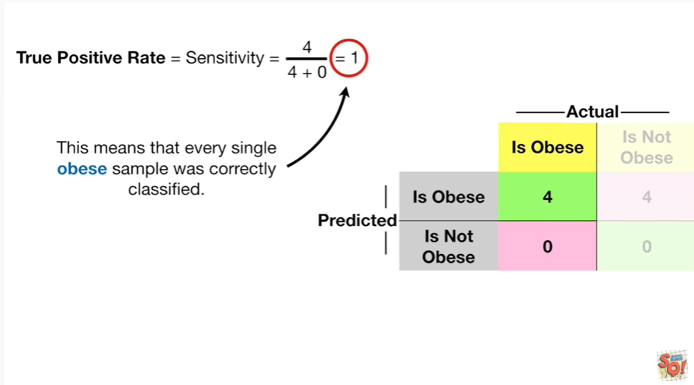

This means that every single obese sample was correctly classified.

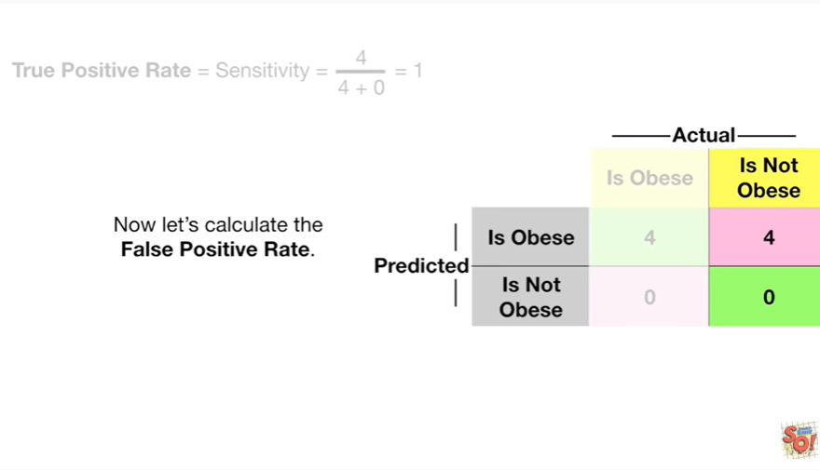

Now let's calculate the false positive rate.

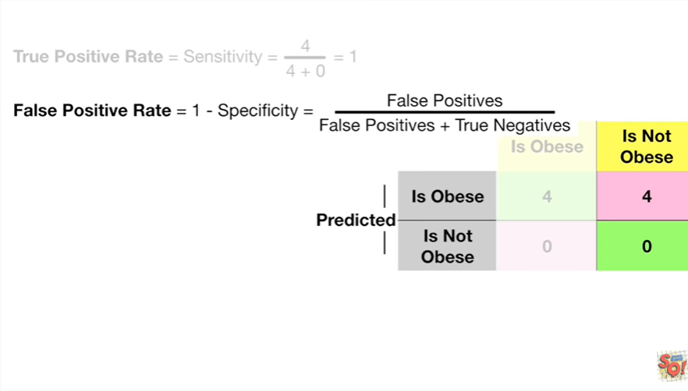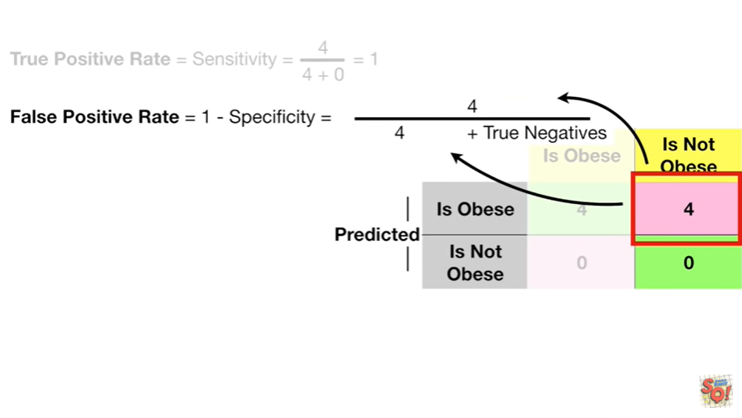

There were four false positives in the confusion matrix

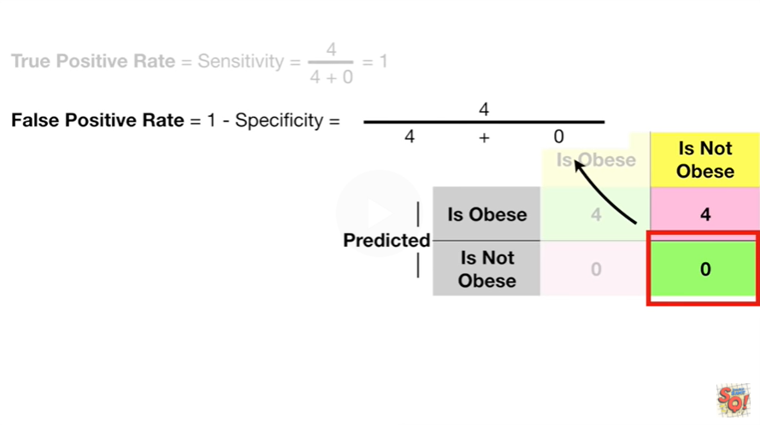

and there were zero true negatives.

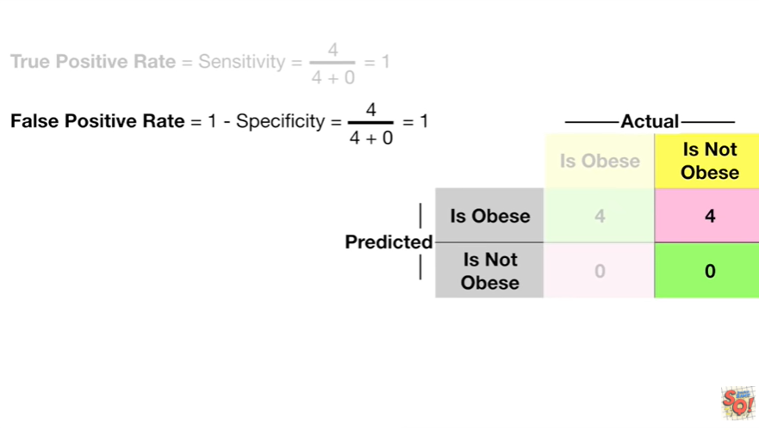

Doing the math gives us one.

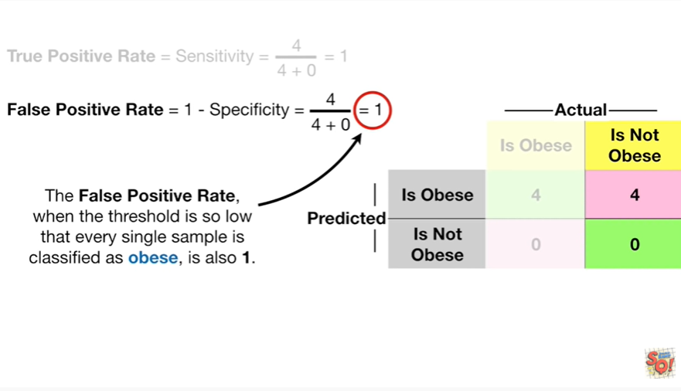

The false positive rate when the threshold is so low that every single sample is classified as obese is also one.

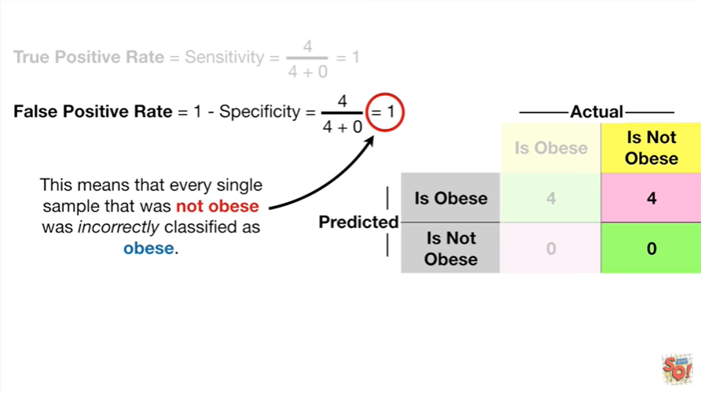

This means that every single sample that was not obese was incorrectly classified as obese.

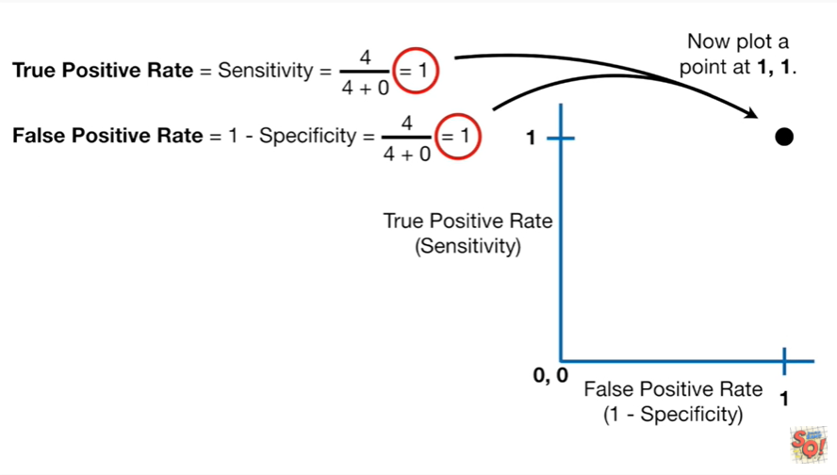

Now plot a point at 1 comma 1.

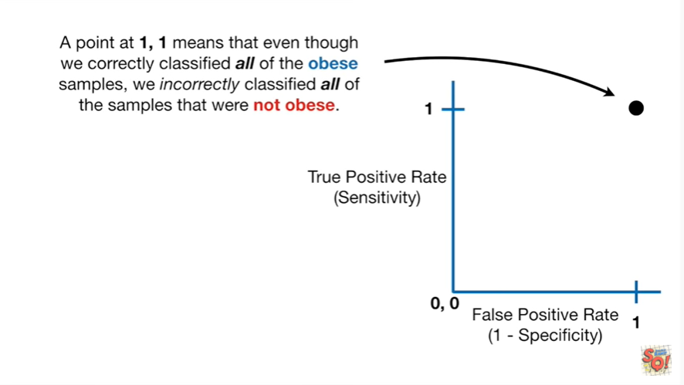

A point at 1 comma 1 means that even though we correctly classified all of the obese samples we incorrectly classified all of the samples that were not obese.

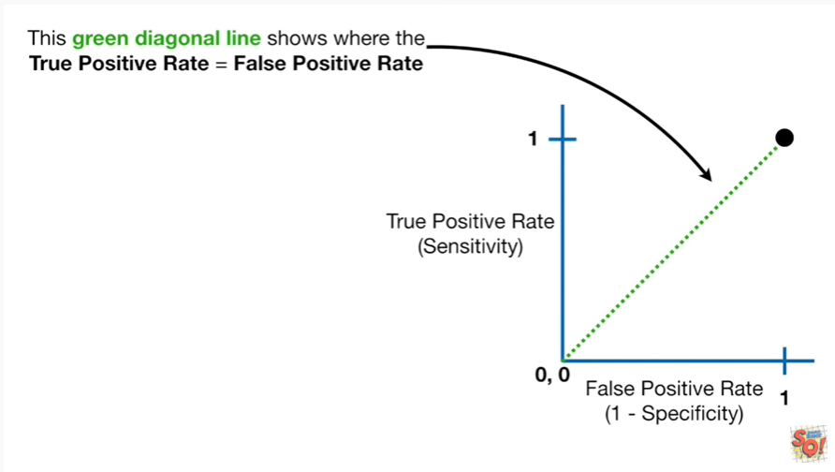

This green diagonal line shows where the true positive rate equals the false positive rate.

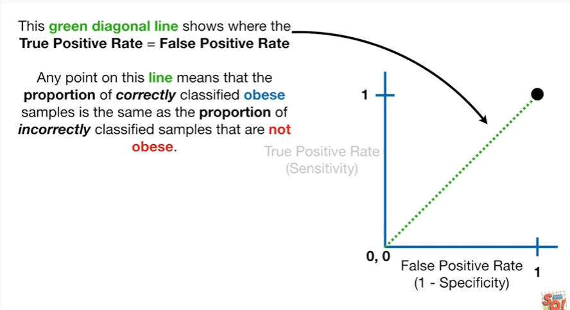

Any point on this line means that the proportion of correctly classified obese samples is the same as the proportion of incorrectly classified samples that are not obese.

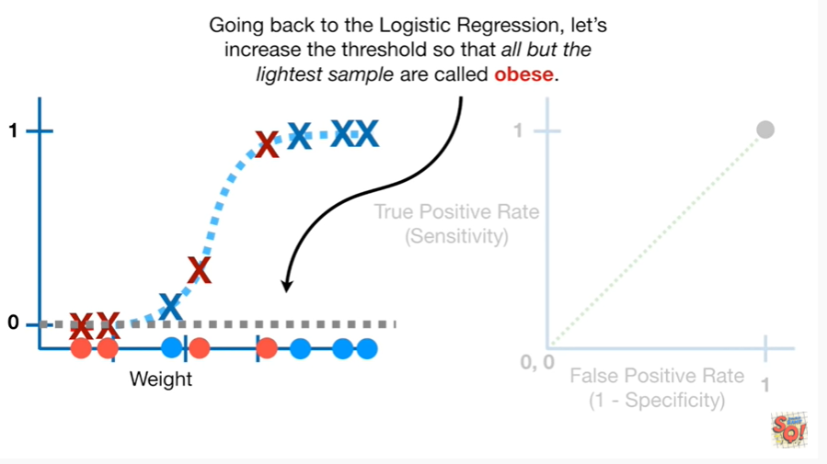

Going back to the logistic regression let's increase the threshold so that all but the lightest sample are called obese.

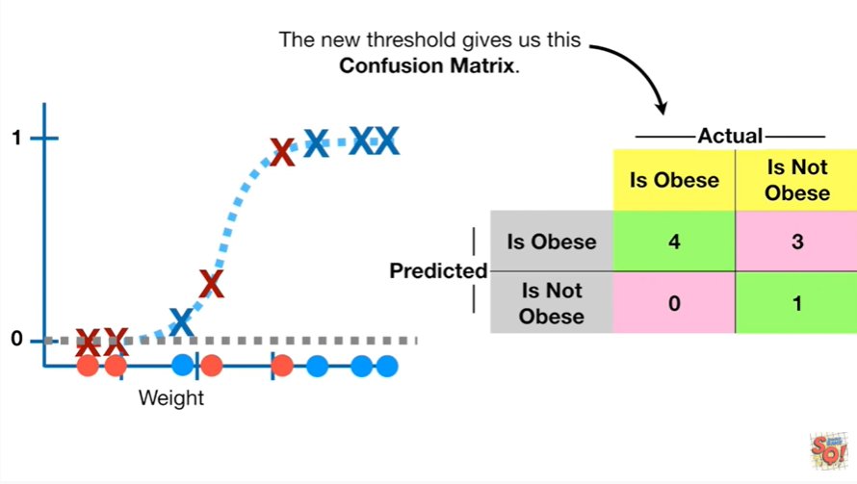

The new threshold gives us this confusion matrix.

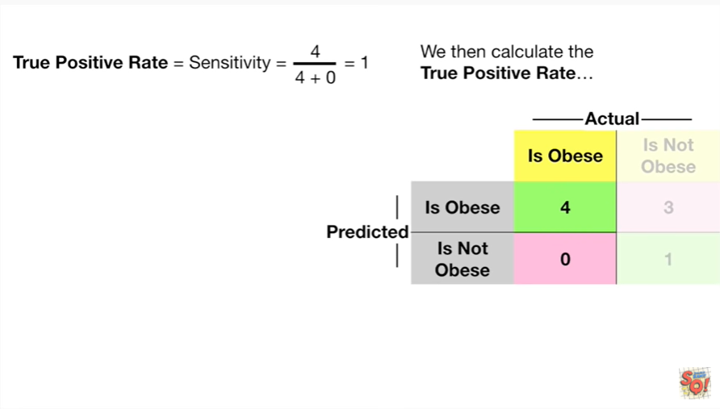

We then calculate the true positive rate

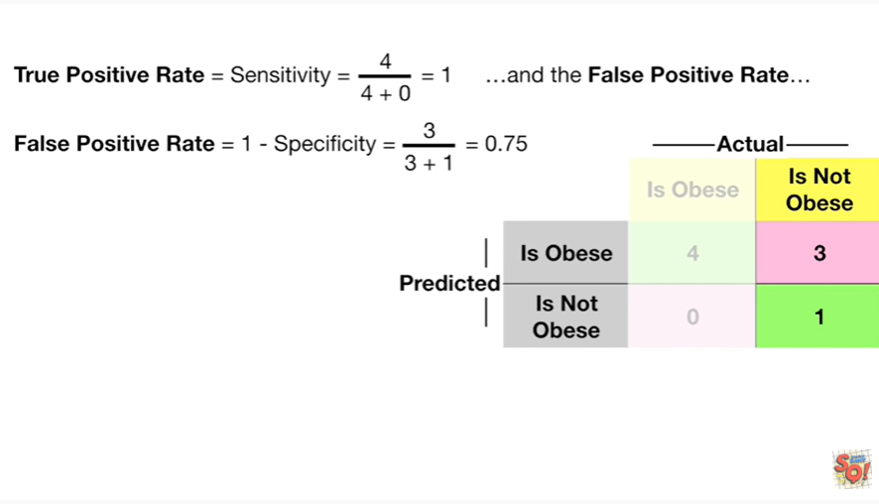

and the false positive rate

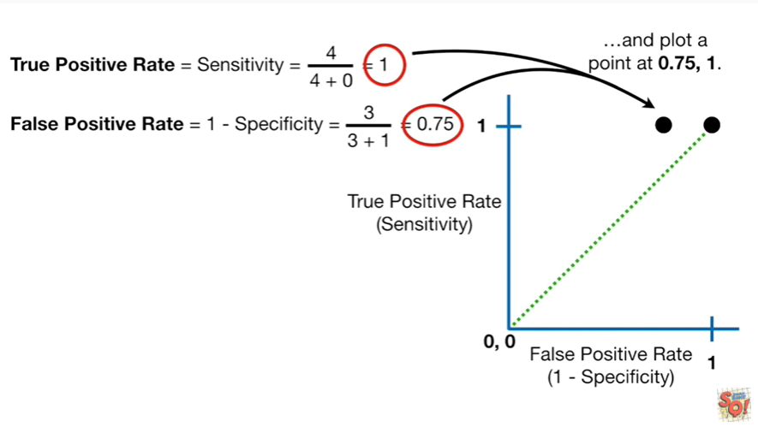

and plot a point at 0.75 comma 1.

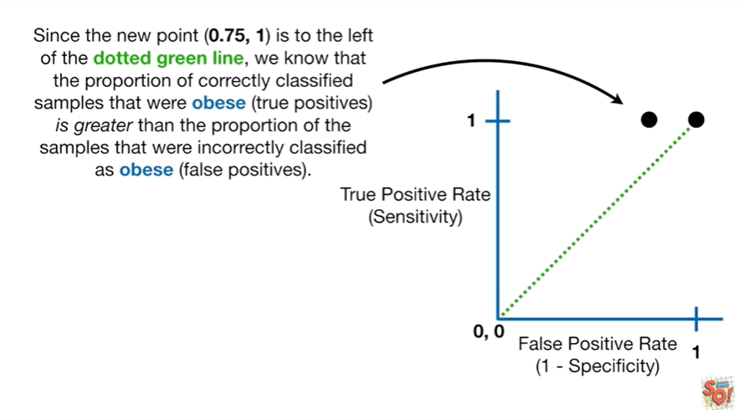

Since the new point is to the left of the dotted green line we know that the proportion of correctly classified samples that were obese is greater than the proportion of samples that were incorrectly classified as obese.

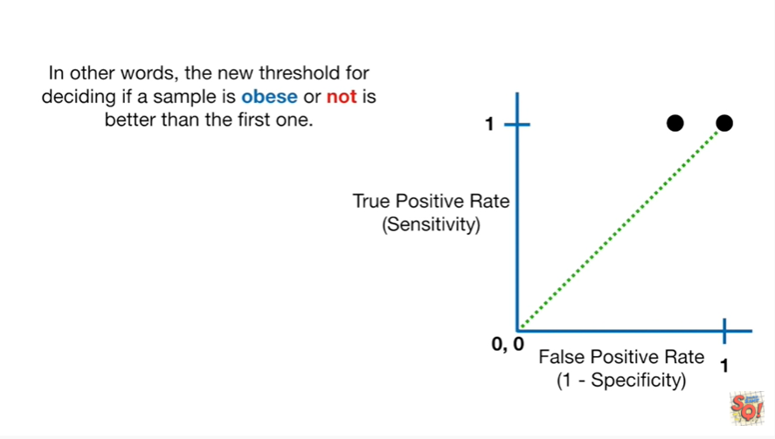

In other words the new threshold for deciding of a sample as obese or not is better than the first one.

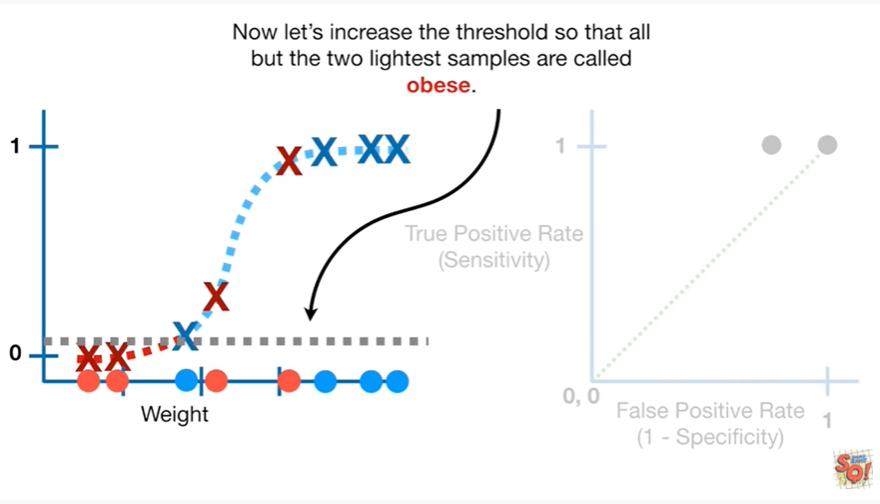

Now let's increase the threshold so that all but the two lightest samples are called obese.

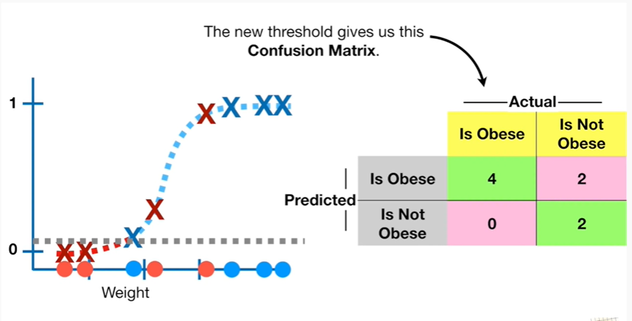

The new threshold gives us this confusion matrix.

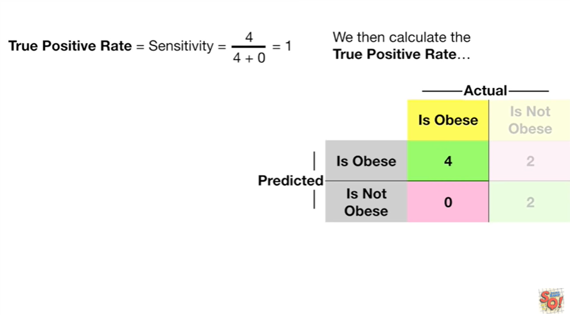

We then calculate the true positive rate

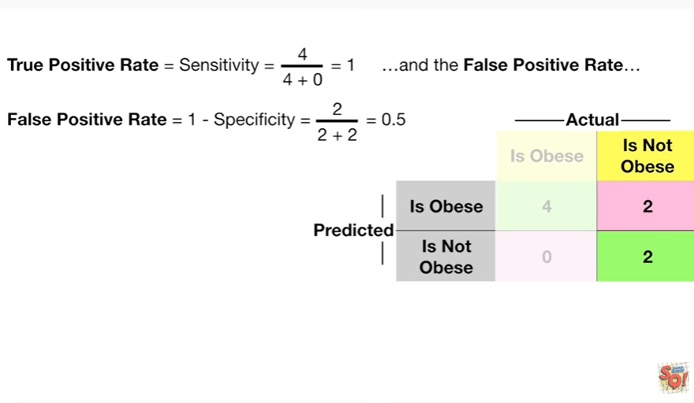

and the false positive rate

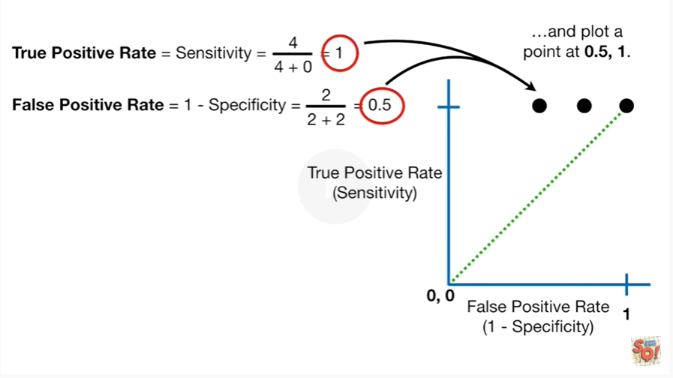

and plot a point at 0.5 comma 1.

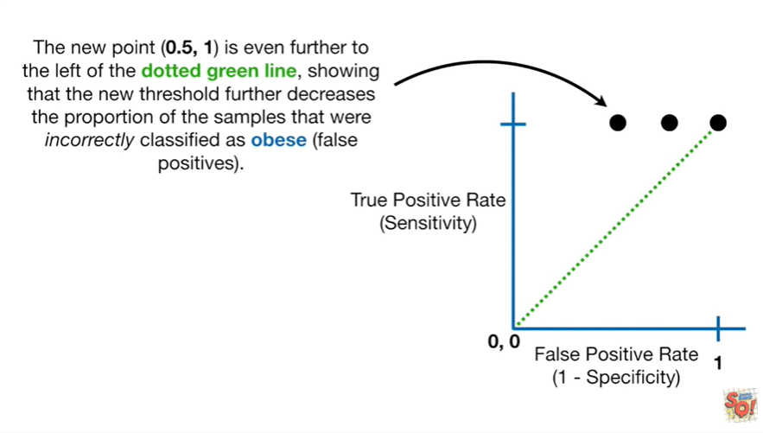

The new point is even further to the left of the dotted green line showing that the new threshold further decreases the proportion of samples that were incorrectly classified as obese.

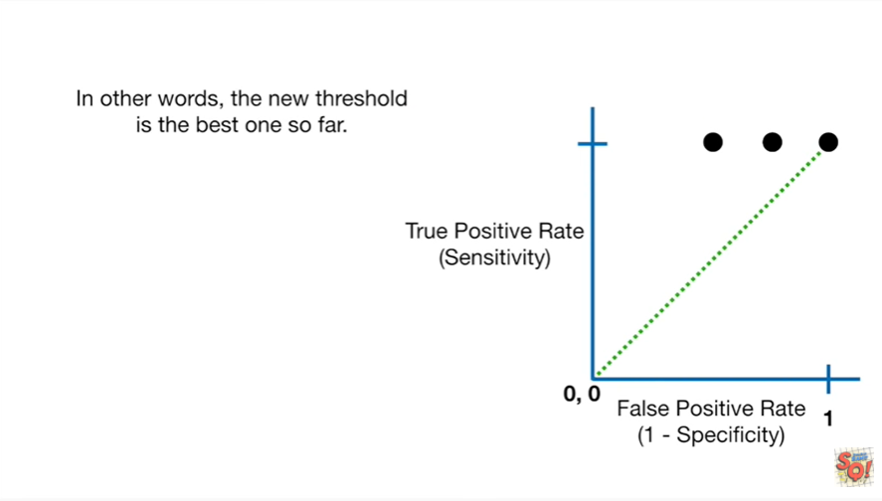

In other words the new threshold is the best one so far.

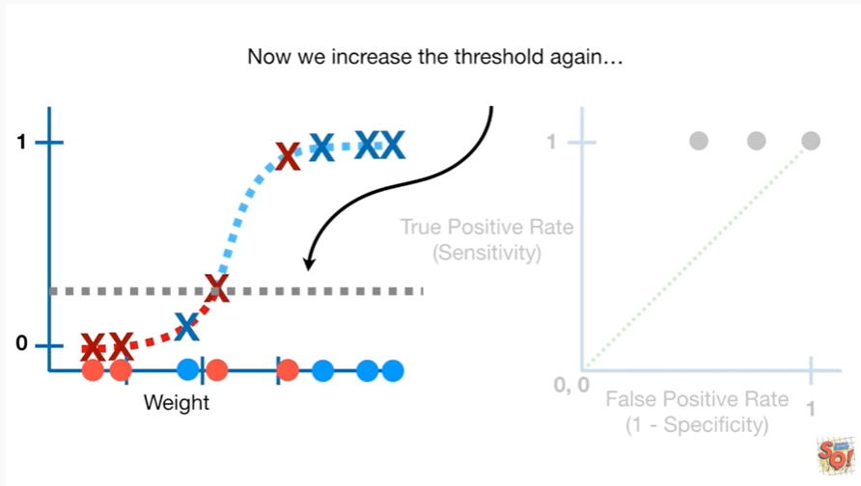

Now we increase the threshold again

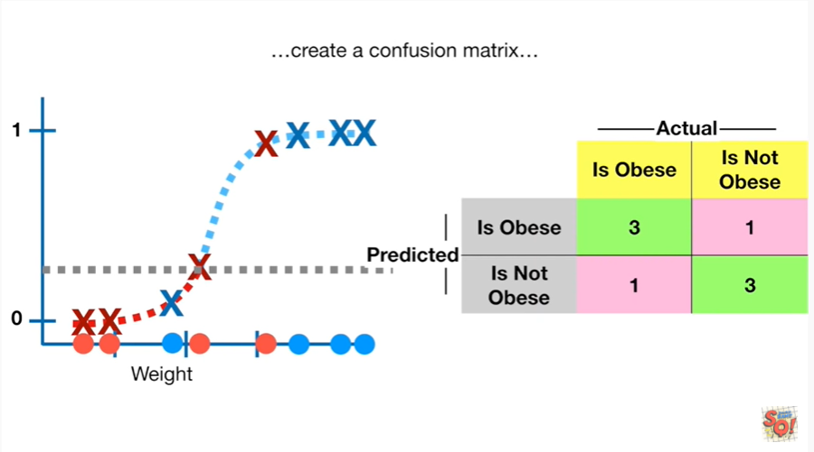

create a confusion matrix

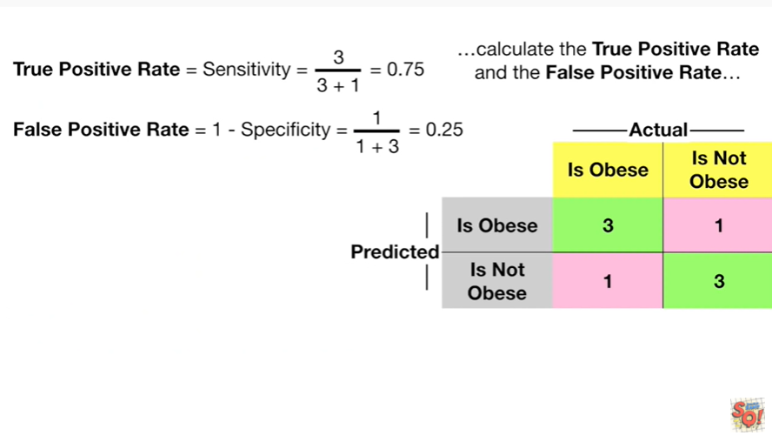

calculate the true positive rate and the false positive rate

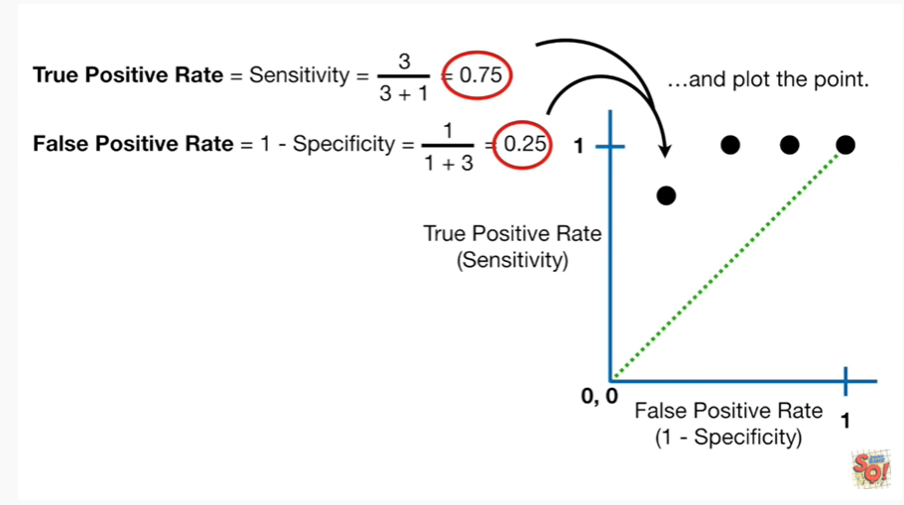

and plot the point.

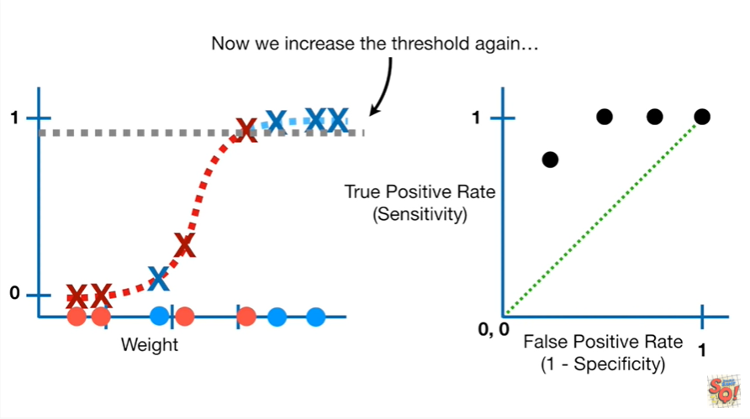

Now we increase the threshold again

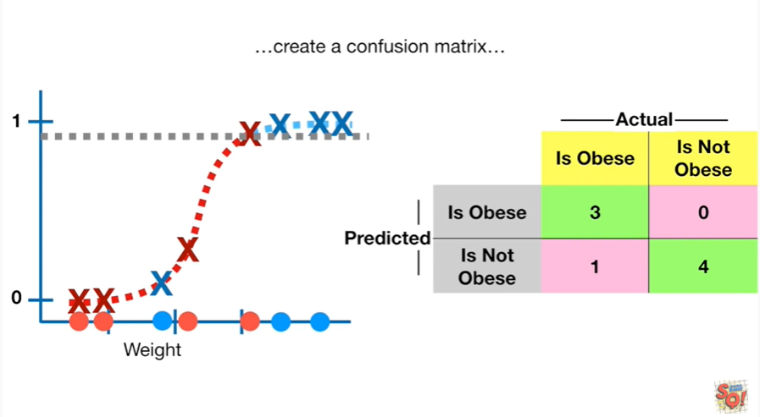

create a confusion matrix

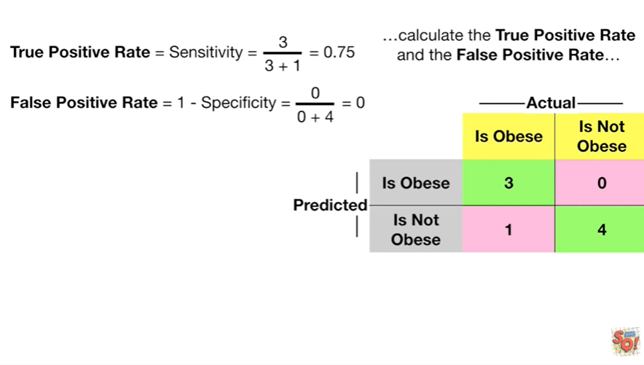

calculate the true positive rate and the false positive rate

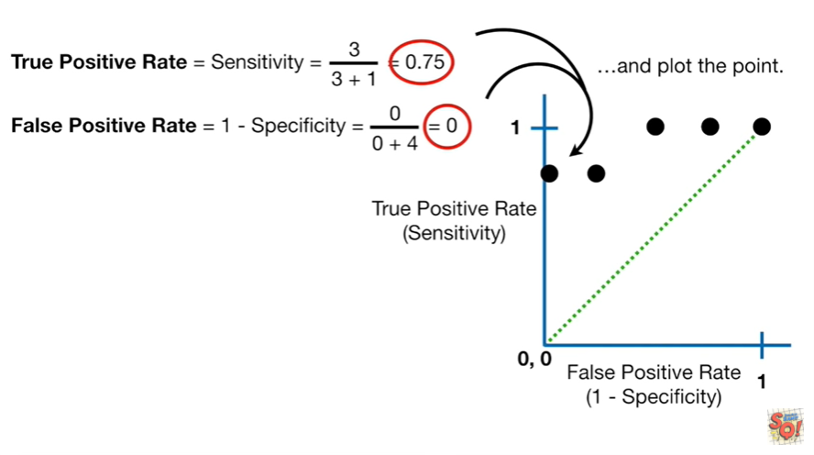

and plot the point.

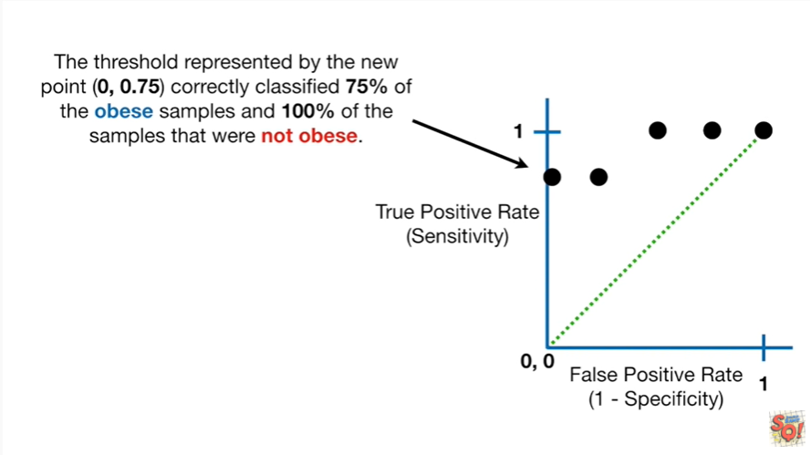

The threshold represented by the new point correctly classifies 75% of the obese samples and 100% of the samples that were not obese.

I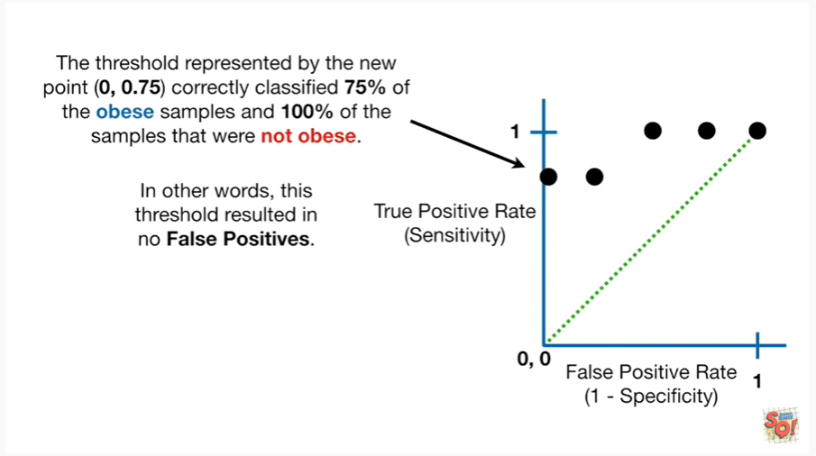n other words this threshold resulted in no false positives.

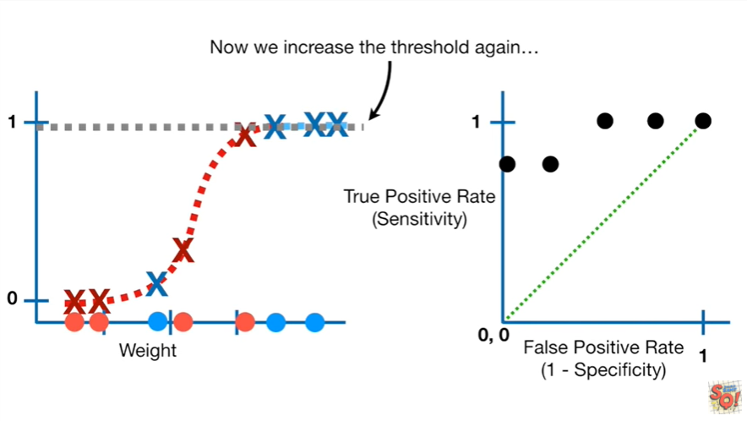

Now we increase the threshold again

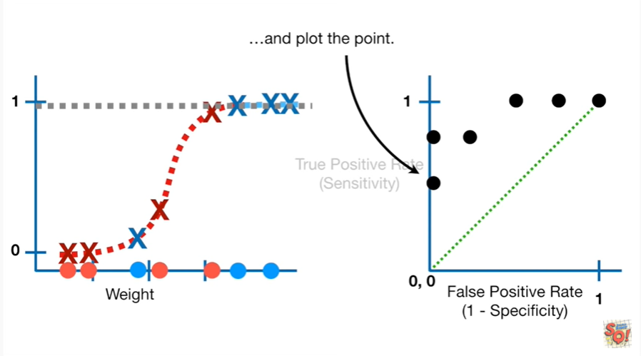

and plot the point.

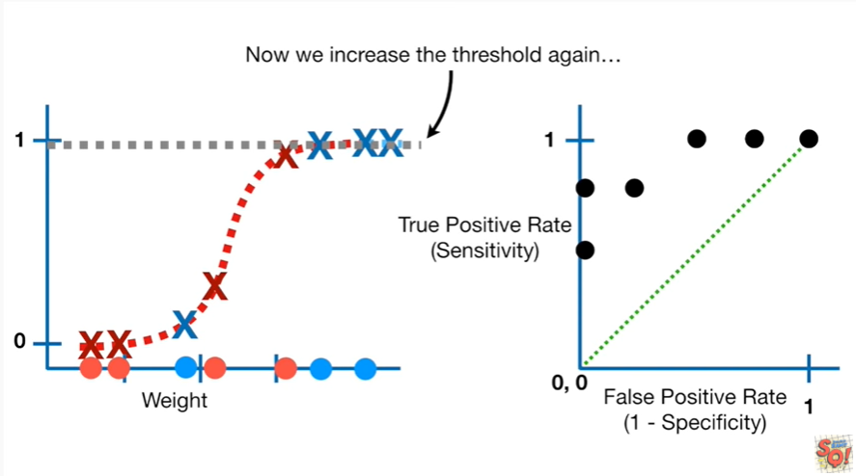

Now we increase the threshold again

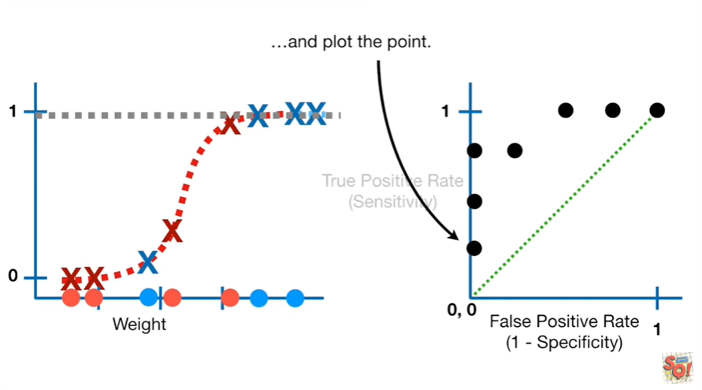

and plot the point.

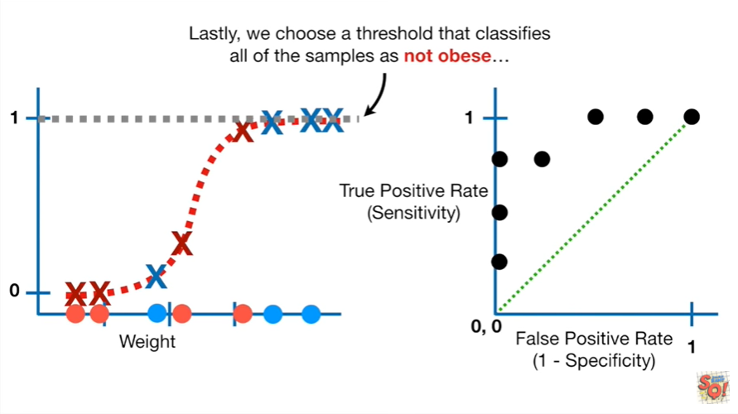

Lastly we choose a threshold that classifies all of the samples as not obese

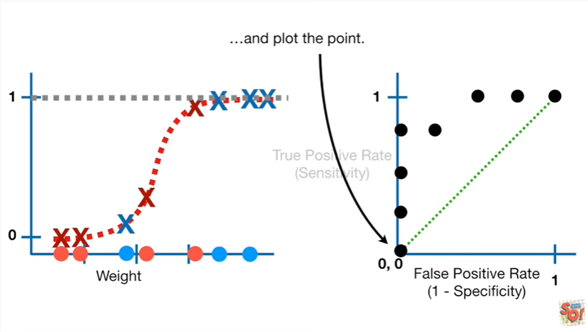

and plot the point.

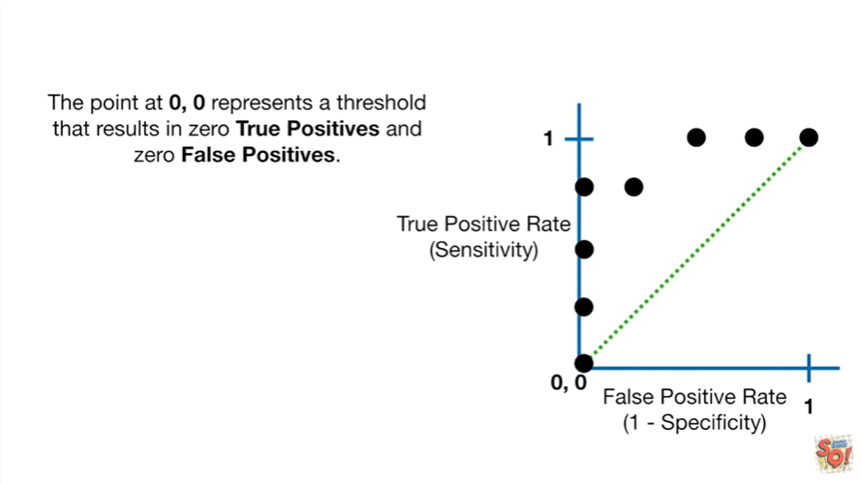

The point at zero comma zero represents a threshold that results in zero true positives and zero false positives.

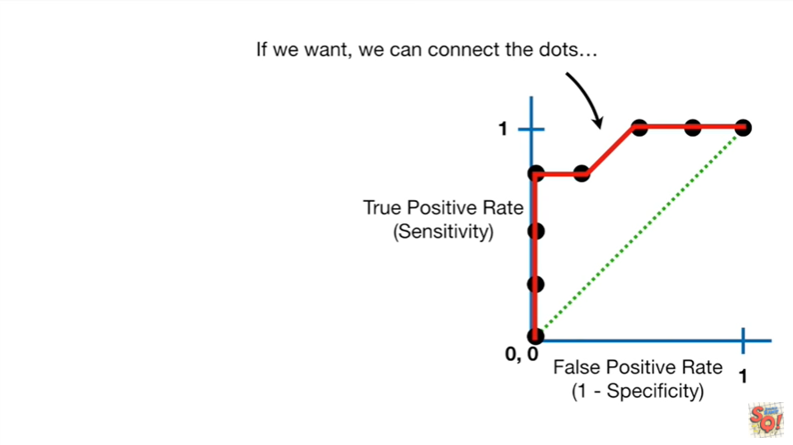

If we want we can connect the dots

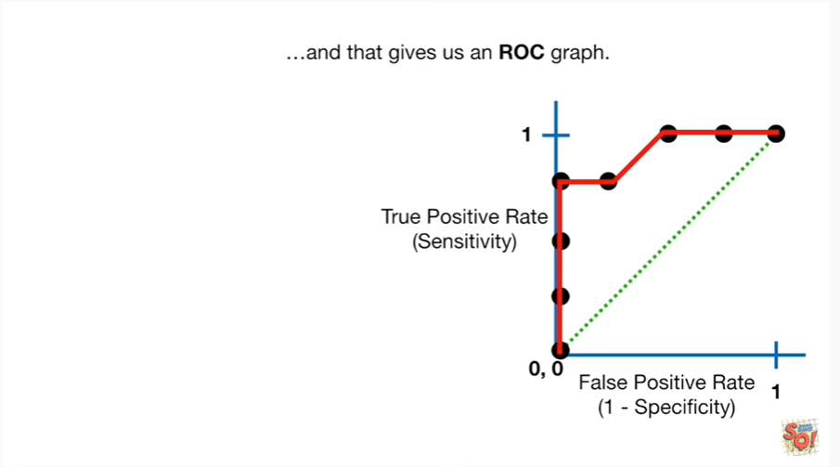

and that gives us an ROC graph.

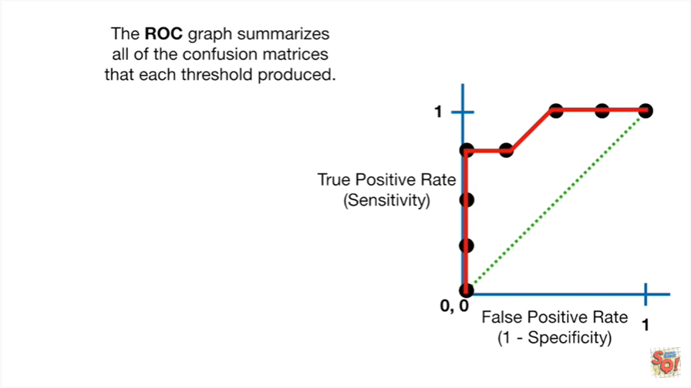

The ROC graph summarizes all of the confusion matrices that each threshold produced.

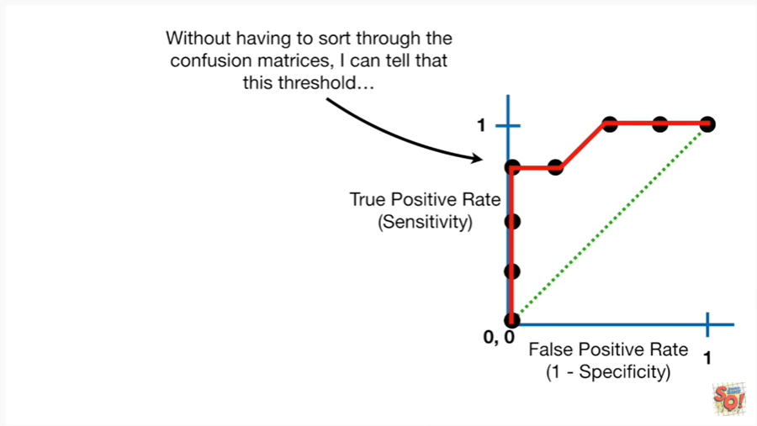

Without having to sort through the confusion matrices I can tell that this threshold

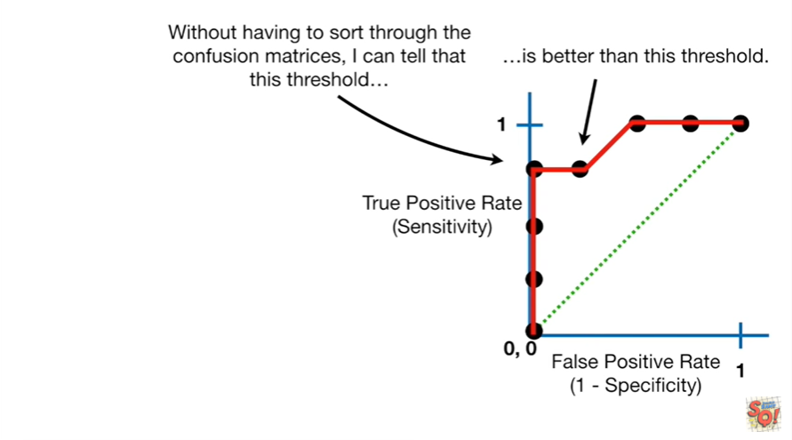

is better than this threshold.

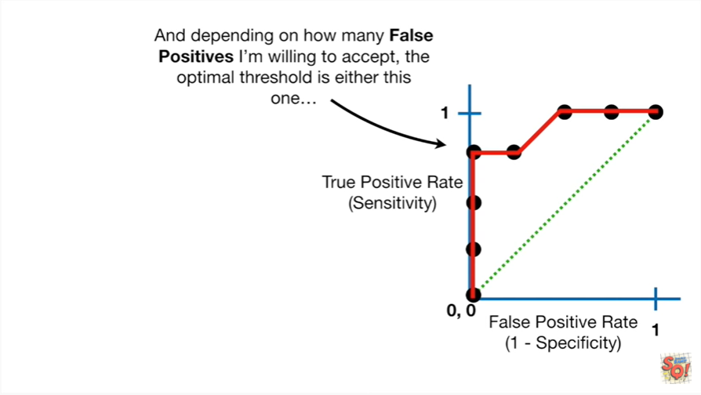

And depending on how many false positives I'm willing to accept the optimal threshold is either this one

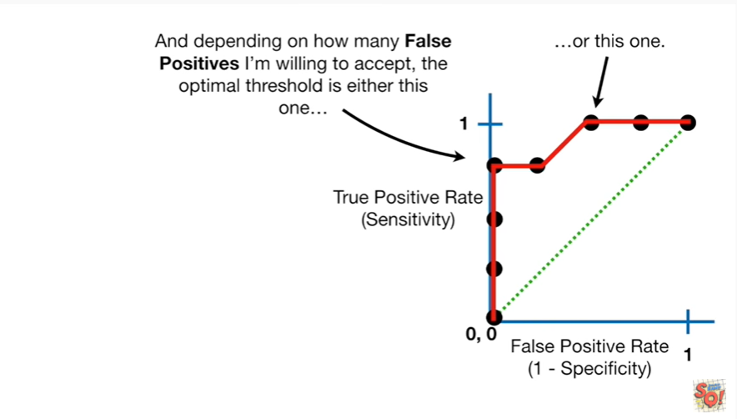

or this one.

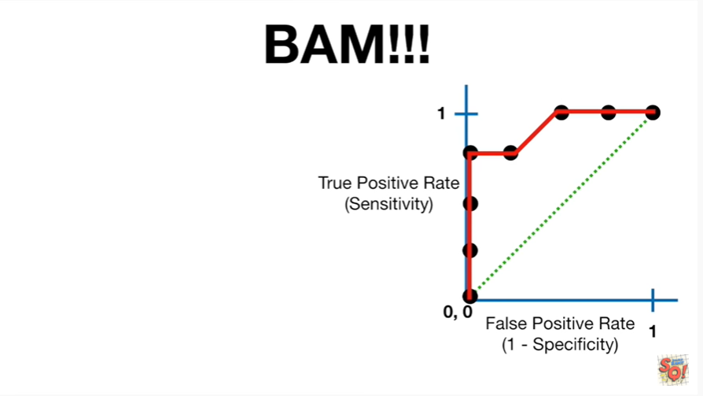

BAM !!!

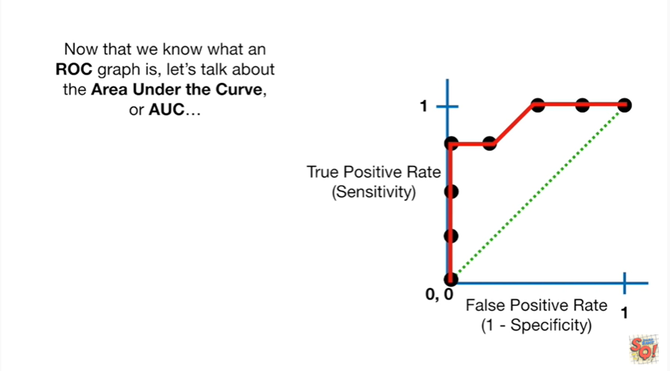

Now that we know what an ROC graph is, let's talk about the area under the curve or AUC.

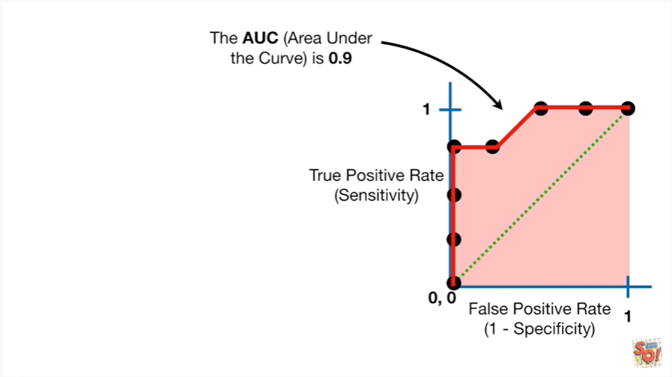

The AUC is 0.9.

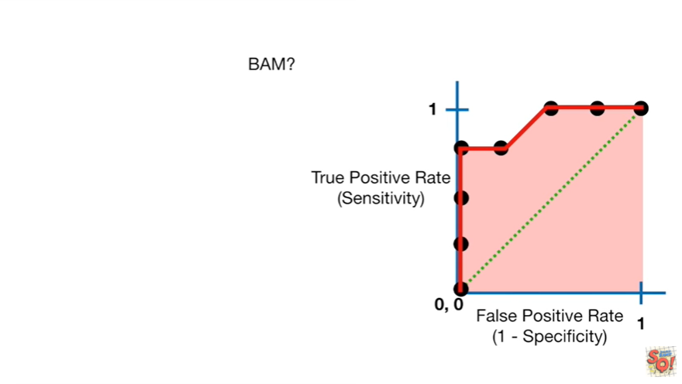

BAM ?

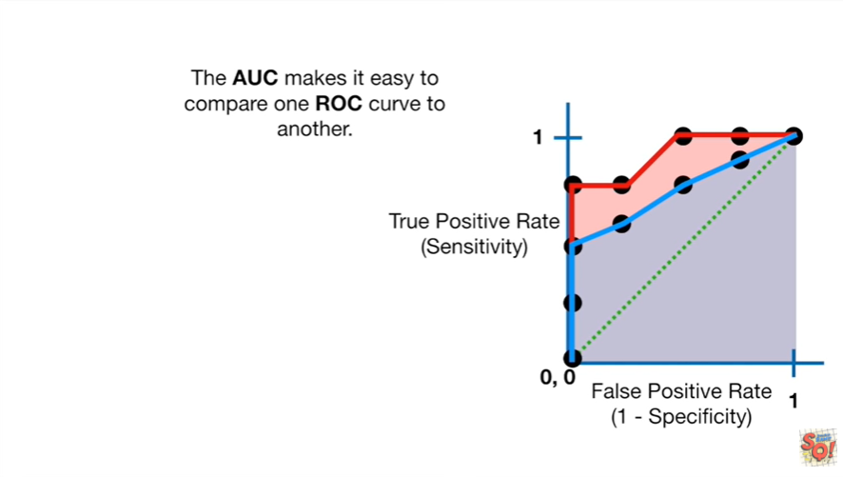

The AUC makes it easy to compare one ROC curve to another.

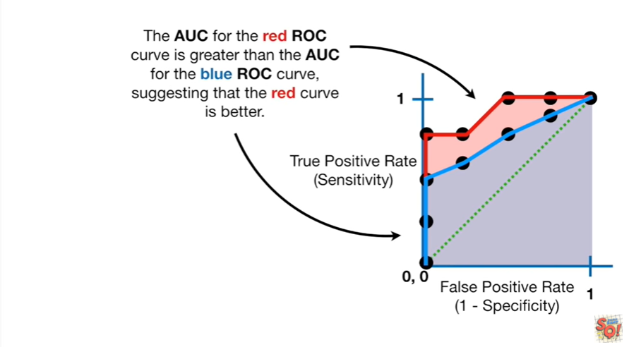

The AUC for the red ROC curve is greater than the AUC for the blue ROC curve, suggesting that the red curve is better.

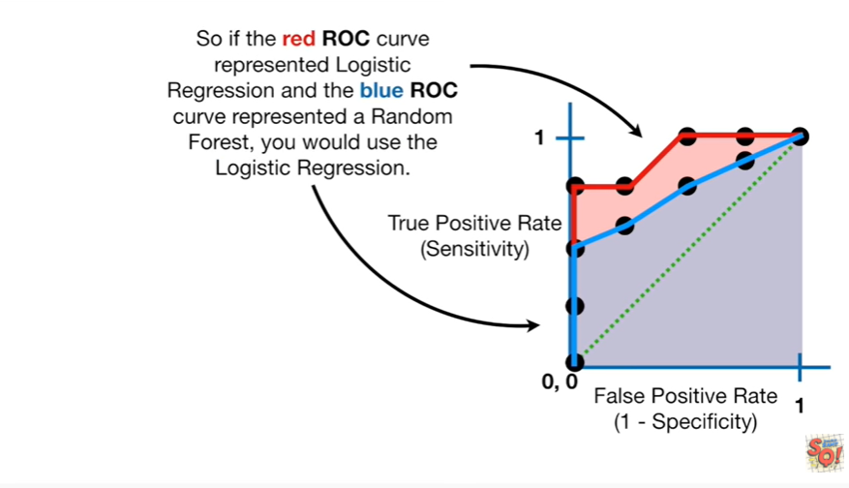

So if the red ROC curve represented logistic regression and the blue ROC curve represented a random forest, he would use the logistic regression.

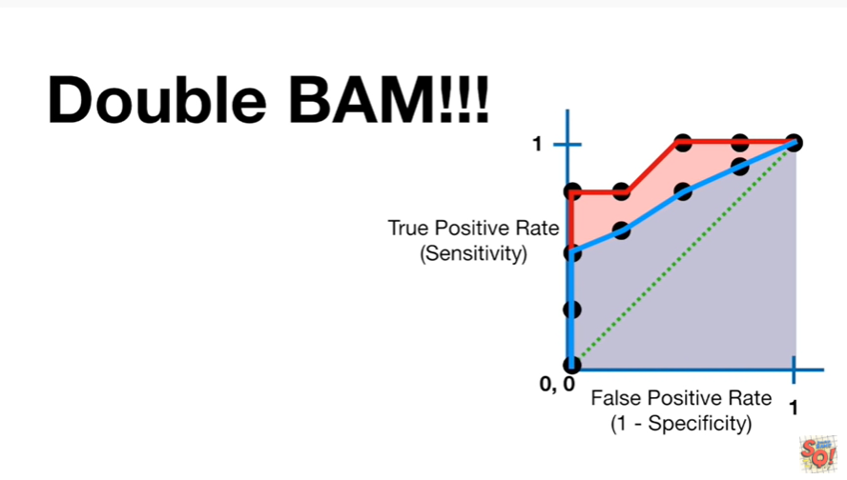

Double bam !!!



Now one last thing before we're all done.

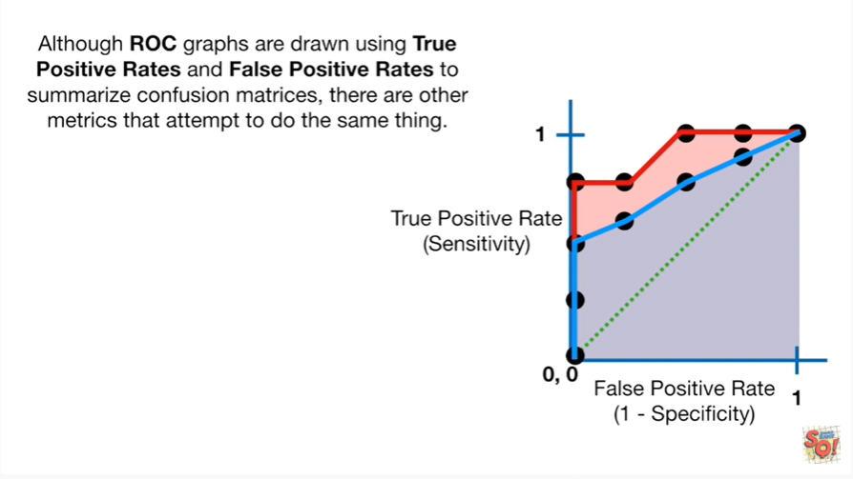

Although ROC graphs are drawn using true positive race and false positive rates to summarize confusion matrices there are other metrics that attempt to do the same thing.

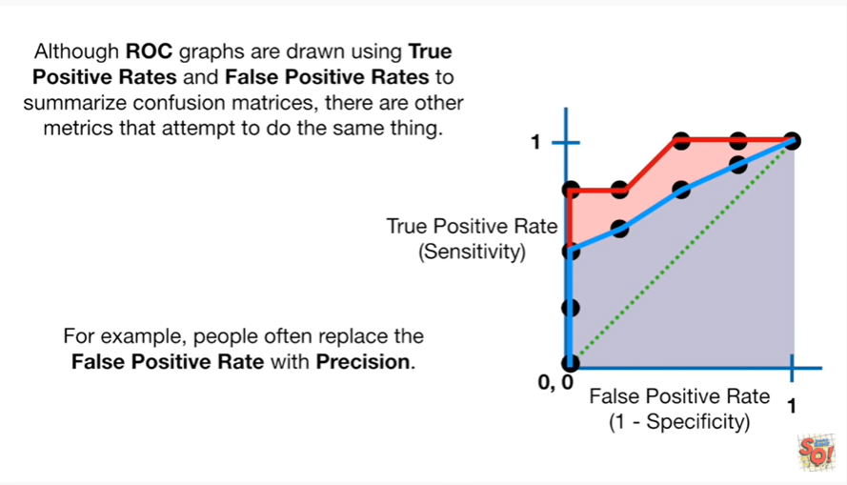

For example people often replace the false positive rate with precision .

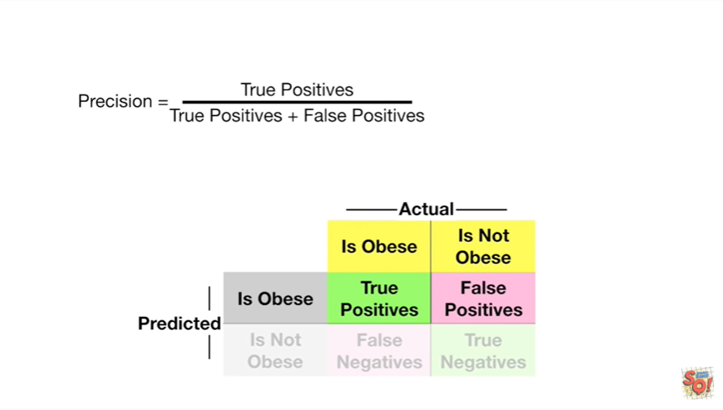

Precision is the true positives divided by the sum of the true positives and false positives.

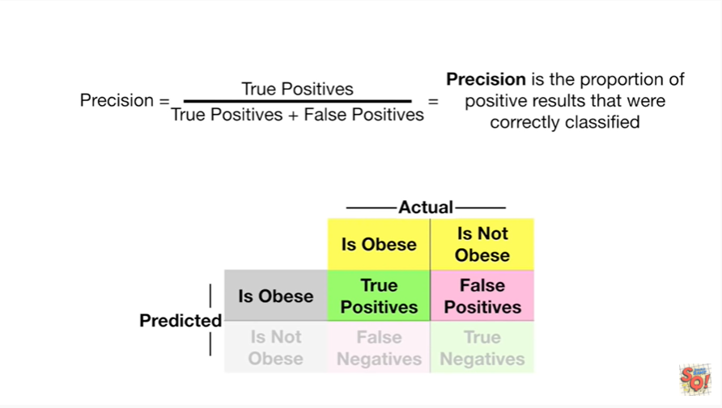

Precision is the proportion of positive results that were correctly classified.

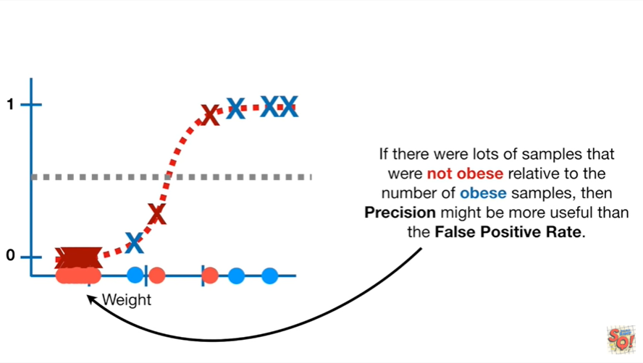

If there were lots of samples that were not obese relative to the number of obese samples, then precision might be more useful than the false positive rate.

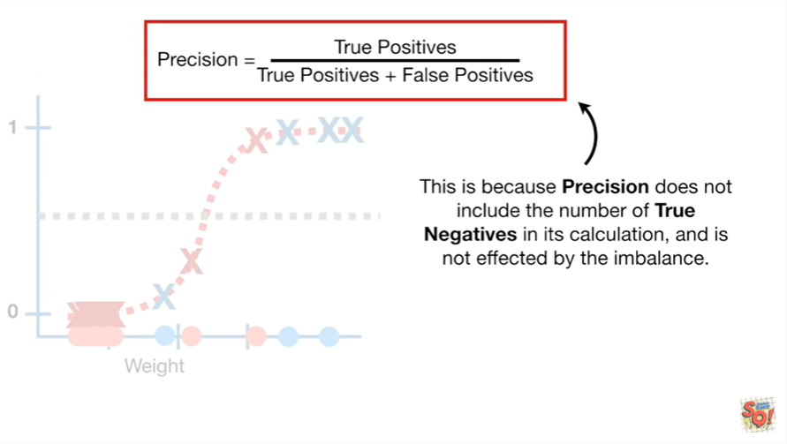

This is because precision does not include the number of true negatives in its calculation and is not affected by the imbalance.

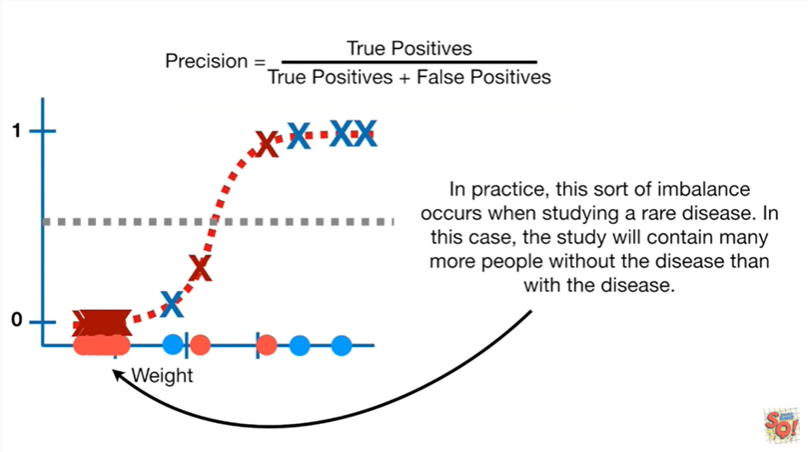

In practice this sort of imbalance occurs when studying a rare disease.

In this case the study will contain many more people without the disease than with the disease.

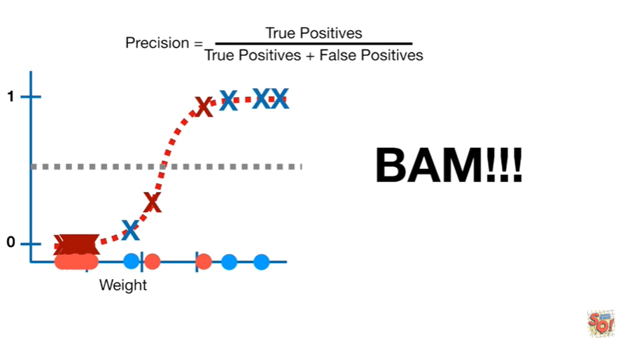

BAM !!!



In summary

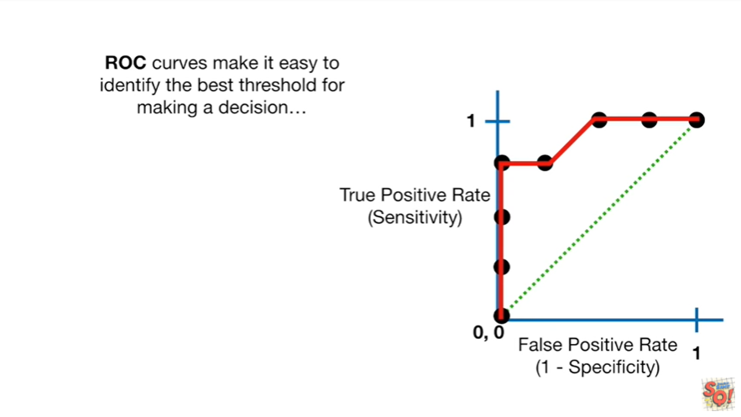

ROC curves make it easy to identify the best threshold for making a decision.

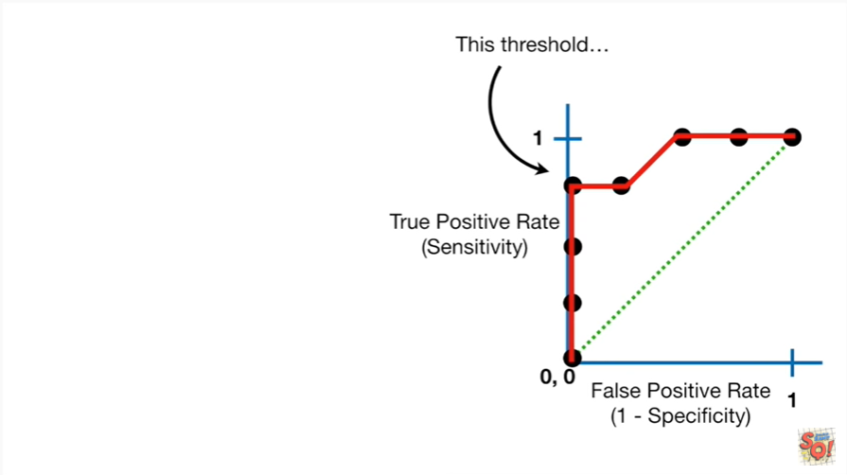

This threshold is better

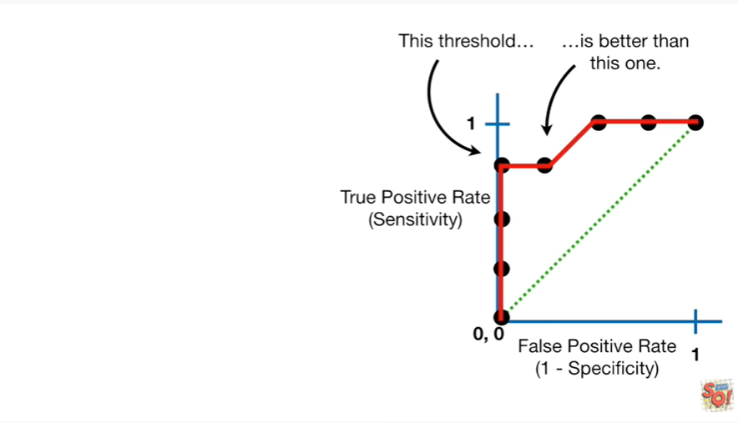

than this one.

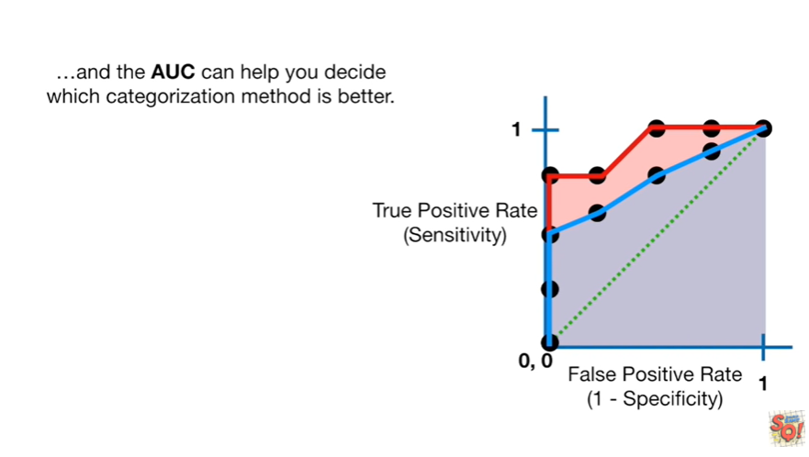

And the AUC can help you decide which categorization method is better.

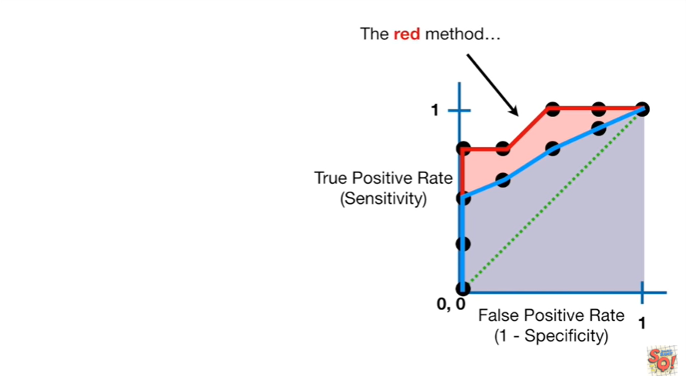

The read method is better

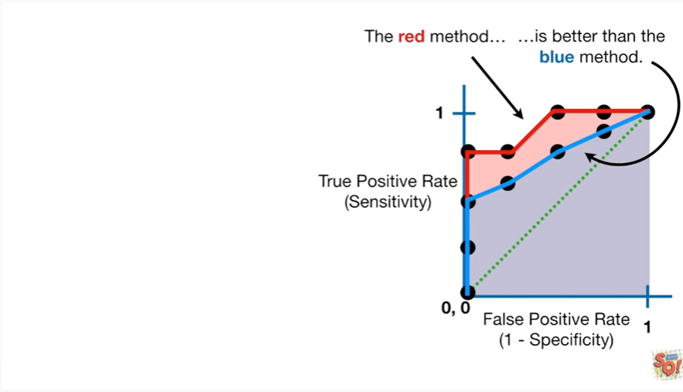

than the blue method.